An Efficient Approach for Dengue Mitigation

A Computational Framework

Nirosha Sumanasinghe Dinayadura

Dissertation Prepared for the Degree of

DOCTOR OF PHILOSOPHY

UNIVERSITY OF NORTH TEXAS

December 2018

APPROVED:

Armin R. Mikler, Major Professor

Chetan Tiwari, Committee Member

Ranee Bryce, Committee Member

Song Fu, Committee Member

Barrett Bryant, Chair of the Department of Computer Science and Engineering

Yan Huang, Interim Dean of the College of Engineering

Victor Prybutok, Dean of the Toulous Graduate School

COPYRIGHT NOTICE

Copyright 2018

By

Nirosha Sumanasinghe Dinayadura

ACKNOWLEDGEMENTS

My first debt of gratitude must go to my advisor, Dr. Armin R. Mikler. He patiently provided the vision, encouragement and advice necessary for me to move forward through the doctoral program and complete my dissertation. He has been a strong and supportive adviser to me throughout my graduate school career. Completing my PhD degree is the most challenging activity of life. It has been a great opportunity to spend several years in the Department of Computer Science and Engineering, University of North Texas, and I am always glad to have a good relationship with the members of the department.

Special thanks to my committee, Dr. Chetan Tiwari, Dr. Song Fu and Dr. Renee Bryce for their support, guidance and helpful suggestions. Their guidance has served me well and I owe them my heartfelt appreciation. Members of CERL Lab also deserve my sincerest thanks, their friendship and assistance has meant more to me than I could ever express.

TABLE OF CONTENTS

Contents

CHAPTER 1 INTRODUCTION 1

1.1 Global Burden of Dengue 2

1.2 Status and Trends of Dengue Disease 3

1.2.1 Dengue Status of Sri Lanka 3

1.3 Questions to be Addressed 8

1.4 Contribution 9

CHAPTER 2 Background 12

2.1. The Geography of Sri Lanka 12

2.2 Rainfall of Sri Lanka 13

2.3 Temperature of Sri Lanka 14

2.4 Climate Seasons of Sri Lanka 15

2.5 The Geography of Thailand 18

3.3 The Dengue Epidemic of Sri Lanka 20

3.4 The Virus and the Vector 21

3.5 REPLAN Framework 22

CHAPTER 3 Related work 24

3.1 Dengue Epidemic 24

3.2 Forecasting /Prediction 27

3.2.1 GIS and Statistical Models 27

3.2.2 Neural Network 28

3.2.3 Cellular Automata 29

3.2.4 Support Vector Machine 31

CHAPTER 4 METHODOLOGY 36

4.1 Data Acquisition 37

4.1.1 Rainfall Data 37

4.1.2 Temperature Data 39

4.1.3 Dengue Case Data 39

4.1.4 Population Data 40

4.2 Data Processing 40

4.2.1 Extracting Relevant Data and Alignment of Time Resolution 40

4.3 Pre-analysis of Data 42

4.4 Pre-processing of Data 43

4.4.1 Yearly Data Normalization to Eliminate Year Specific Influences 43

4.4.2 Outlier Removal 45

4.5 Model Generation 48

4.5.1 Support Vector Regression 48

4.5.2 k-Nearest Neighbor Regression 52

4.5.3 Least Square Regression 53

4.6 Prediction 53

4.7 Model Validation 54

4.7.1 Determination of the Degree of Fit of the Regression Model to the Dataset with Parameter Alpha (α). 55

4.7.2 10—Fold Cross Validation 56

4.8 Resource Allocation 56

4.8.1 Problem Definition 57

4.8.2 Problem Representation 57

4.8.3 Digital Representation 58

4.8.4 Finding the Optimum Solution for Resource Allocation Problem 59

4.8.5 Weight Adjustments 59

4.8.6 GA Representation of the Problem 61

4.8.7 Proposed Population Generation Procedure 62

4.8.8 Proposed Crossover Operation 62

4.8.9 Proposed Mutation Operation 63

4.8.10 Fitness function 64

4.8.12 Proposed Sliding Mutation Scheme 66

4.8.13 Time and Space Complexity Analysis of the Proposed GA 68

CHAPTER 5 Results: 70

5.1 Pre-analysis of Data 70

5.2 Preprocessing of Data 71

5.2.1 Data Normalization 71

5.2.2 Outlier Removal with Convex Hull Iterative Approach 72

5.3 Results of GWR and Least Square Analysis of Dengue Epidemics in Sri Lanka 75

5.3.1 Least Square Analysis 75

5.3.2 Geographically Weighted Regression (GWR) analysis 76

5.4 Generating Prediction Models for Dengue Epidemic in Thailand 80

5.4.2 Prediction Results for a Global Model 84

5.4.3 Prediction Results for Local Models 86

5.5 Resource Allocation 88

5.5.1 Trial 1 89

5.5.2 Trial 2 93

5.5.3 Trial 3 95

5.5.4 Trial 4 97

5.6 Comparison of Proposed GA with Sliding Mutation against Standard GA with Random Allocation and Mutation 99

CHAPTER 6 SUMMARY AND FUTURE DIRECTIONS 103

6.1 Future Directions 108

BIBLIOGRAPHY 111

LIST OF TABLES

Table 2.1 Seasonal Rainfall (mm) in Thailand 20

Table 2.2 Temperature (Celsius Degree - °C) in Thailand 20

Table 4.1 GSMap text area declaration for Asian region [14] 38

Table 4.2 Fragment of rainfall data text file from GSMap_NRT 41

Table 4.3 Correlation values and their meanings 43

Table 5.1 Correlation Coefficient for Three Levels of Outlier Removals on Global Dataset 85

Table 5.2 Results of 10-fold Cross Validation of SVR on Global Dataset 86

Table 5.3 Experimental Trial Setup 89

Table 5.4 Facility Information (High risk facility is highlighted) 89

Table 5.5 Resource Availability 89

Table 5.6 Requested Resources from each facility 90

Table 5.7 Lock Chromosome 90

LIST OF FIGURES

Figure 1.1 Dengue risk map for year 2009 3

Figure 1.2 Dengue annual case rates reported weekly in year 2017 4

Figure 1.3 Dengue trend for years 2010-2016 in Sri Lanka 6

Figure 1.4 Dengue case trends from 2000 to 2018 in Sri Lanka 6

Figure 1.5 Number of reported dengue disease cases and dengue disease incidence, Thailand, 2000–2011 7

Figure 1.6 Number of reported cases of dengue disease, by month, Thailand, 2000–2012 8

Figure 2.1(a) Provinces (b) Districts of Sri Lanka 13

Figure 2.2 Annual rainfalls in Sri Lanka(Courtesy: Department of Meteorology Sri Lanka) 14

Figure 2.3 Average temperatures from 1961 to 2015 for (a) April (b) August and (c) January (Courtesy: Department of Meteorology Sri Lanka) 15

Figure 2.4 Distribution of rainfall in First Inter-monsoon Season (Courtesy: Department of Meteorology Sri Lanka) 16

Figure 2.5 rainfall distributions for Southwest -monsoon Season (Courtesy: Department of Meteorology Sri Lanka) 16

Figure 2.6 rainfall distributions for Second Inter-monsoon Season (Courtesy: Department of Meteorology Sri Lanka) 17

Figure 2.7 rainfall distributions for Northeast -monsoon Season (Courtesy: Department of Meteorology Sri Lanka) 17

Figure 2.8 Provinces of Thailand (Courtesy: Wikipedia) 19

Figure 4.1 Proposed Work-Flow for Dengue Epidemic Mitigation 36

Figure 4.2 Definition of text areas of JAXA data repository for text data [14] 38

Figure 4.3 Rain fall data observation points and geographical boundaries of all four provinces 41

Figure 4.4 Monthly Rainfall and Incidence Data for Six Years from 2010 44

Figure 4.5 Normalized Monthly Rainfall and Incidence Data for Six Years from 2010 45

Figure 4.6 Outliers in Data Points 46

Figure 4.7 Outlier Removal Levels 46

Figure 4.8 Three Levels of Outlier Removals 47

Figure 4.9 Accuracy Calculation of SVR 55

Figure 4.10 Bi-Partite Graph of Resource Mapping 58

Figure 4.11 The Modified Chromosome for Genetic Algorithm 61

Figure 4.12 Proposed Cross-Over Operation 63

Figure 4.13 The Proposed Mutation Operation 64

Figure 4.14 The Lock Chromosome for two facilities with five resources. First resource is abundant and hence locked. 66

Figure 4.15 Standard and Proposed GA for resource allocation 67

Figure 5.1 Correlation between Rainfall and Dengue Incidence for Raw Data 70

Figure 5.2 Correlation comparison with and without Normalization 72

Figure 5.3 Multi Level Outlier Removal with Convex Hulls (v1-rainfall, v2-dengue incidence) 73

Figure 5.4 Correlation for all Districts at each Outlier Removal Level 74

Figure 5.5 The spatial distribution of dengue incidence from 2011 to 2015 in Sri Lanka. 76

Figure 5.6 The GWR standard residual map for dengue incidence with rainfall and population density for the year 2014. 77

Figure 5.7 The spatial distribution of regression coefficients for (a) population density (b) rainfall. 80

Figure 5.8a Dengue Incidence Map of Thailand in 2011 81

Figure 5.8b Dengue Incidence Map of Thailand in 2012 82

Figure 5.8c Dengue Incidence Map of Thailand in 2013 82

Figure 5.8d Dengue Incidence Map of Thailand in 2014 83

Figure 5.8e Dengue Incidence Map of Thailand in 2015 83

Figure 5.9 Plot of Rainfall vs Dengue Incidence for the Global Dataset (v1-rainfall, v2-dengue incidence) 84

Figure 5.10 The model performance without outlier removal 87

Figure 5.11 The model performance with level1 outlier removal 87

Figure 5.12 The model performance with level2 outlier removal 88

Figure 5.13 The performance of proposed GA for 10 facilities requesting 10 resources 91

Figure 5.14 High risk facility 92

Figure 5.15 Lowest risk facility 93

Figure 5.16 Performance of the proposed GA for 50 facilities and 5 resources 94

Figure 5.17 The resource allocation for the high-risk facility of Trail 2 95

Figure 5.18 The performance of the proposed GA for 100 facilities with 10 resources 96

Figure 5.19 The resource allocation for the Trail 3 97

Figure 5.20 The performance of the proposed GA for 500 facilities with 10 resources 98

Figure 5.21 The resource allocation for the Trail 4 99

Figure 5.22 Comparison of standard GA and the proposed GA 102

# INTRODUCTION

Existence of dengue in Sri Lanka links back to the early 1960s and yet dengue has become a major public health issue at present with a high morbidity and mortality. In 2009, dengue infections increased at an alarming rate across Sri Lanka. By the end of the year 2009, 35,095 people were infected, and 346 fatalities reported. The number of infections has never been lower than 28,000 since 2009. In 2013, 47,246 infections were reported. Number of fatalities was 83 in 2013. During the first 10 months of the year 2017, 15,8854 suspected dengue cases have been reported to the Epidemiology Unit of Sri Lanka keeping the mortality rate at an alarming level which was about 300 deaths. There is an urgent need for a comprehensive mitigation plan to manage the impact of the epidemic.

The Presidential Task Force initiated many efforts from Dengue Prevention, to fines for those who neglect breeding grounds, to declaring a national dengue eradication program. Despite these initiatives, the rate of infection is exactly what it was five years ago. Several areas reported a slight reduction in dengue cases after deploying the suggested strategies. The situation is more urgent and alarming in the Western Province, home to over 25 percent of the country’s population of over 20 million people, and to 60 percent of all reported dengue cases since 2009. Western Province (43%) has the highest number of dengue cases reported. The Colombo district is the most affected area.

Trending of dengue cases during recent years indicates that strategies, that have been tried, failed. Experts are now suggesting to get help from the national Meteorological Bureau for the fight against the virus. There is a strong relationship between climate pattern and the spread of dengue disease [1]. The authors further asserted that mosquito breeding grounds increased following heavy rains, pointing out that the two annual peaks in infections were recorded soon after the two annual monsoons. This work also found that warming weather patterns increased the distribution of the dengue-carrying mosquito. Researchers pointed out that detailed weather forecasts could help health authorities to better allocate resources and strategically implement prevention campaigns.

## 1.1 Global Burden of Dengue

World Health Organization reported that dengue incidence has grown exponentially around the world in recent years. Public awareness on dengue epidemics is low and that results in lower number of cases reported to government offices. It is estimated that 390 million dengue cases reported per year [53]. Another study conducted estimates that 3,900 million people living in 128 countries are at risk [54]. The global risk map of dengue epidemic is shown in Figure 1.1.

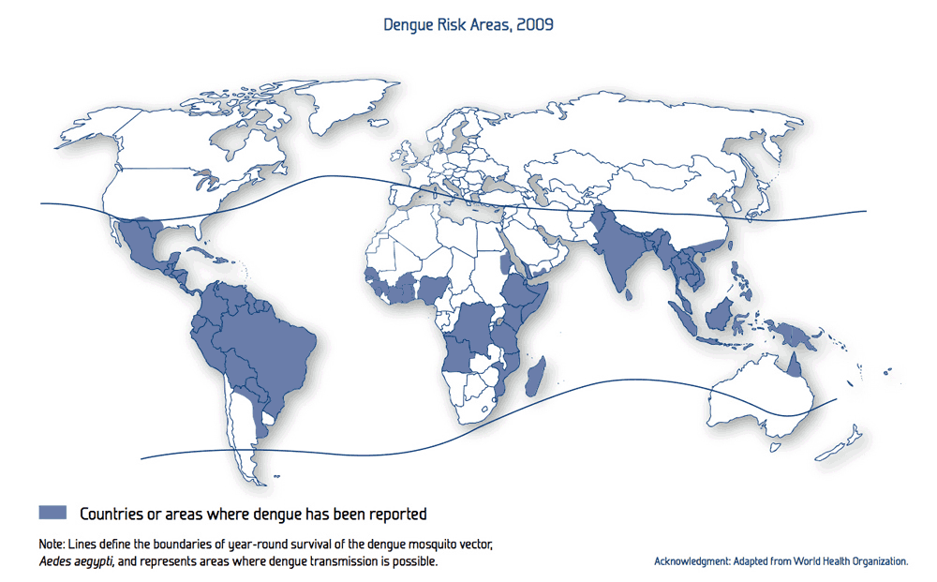

Figure 1.1 Dengue risk map for year 2009

## 1.2 Status and Trends of Dengue Disease

South Asian and Southeast Asian countries have been fighting dengue for decades. The status and the trends of all these countries are homogeneous. In recent years, Sri Lanka has been hit by several major dengue epidemics. A similar situation can be found in Thailand and it has also been hit by several dengue epidemics in recent years. The most recent outbreak took place in Thailand in 2018. The main goal of the proposed work is to build a general model for modelling of dengue epidemic. Therefore, we conducted statistical analysis of dengue disease in Sri Lanka and apply the findings in Thailand for the comparison.

### 1.2.1 Dengue Status of Sri Lanka

It is seen in the global risk map of dengue epidemic that Sri Lanka is in the high-risk area. This is not a coincidence and it is clearly reflected in the reports produced by various institutions in Sri Lanka. In the last quarter of the year 2015, 14,776 dengue patients have been reported to the Epidemiology Unit. In the Western Province, that accounted for 47.11% of total reported cases. The recent development of dengue epidemic in Sri Lanka is alarming. During the first 10 months of the year 2017, 158,854 suspected dengue cases have been reported. The mortality rate was at an alarming level which was about 300 deaths. 37,988 dengue cases have been reported January through September in the current year 2018. Distribution of cases by weeks for the year 2017 is given in the Figure 1.2.

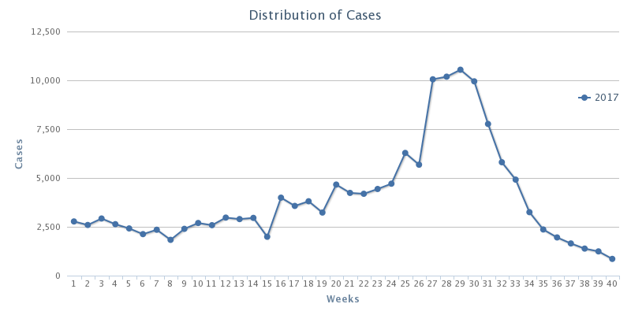

Figure 1.2 Dengue annual case rates reported weekly in year 2017

A committee has been appointed by the government of Sri Lanka to thoroughly study the dengue epidemic and provide recommendations towards the better control of dengue epidemic. The committee comprised of professionals from several fields including medicine, healthcare, environmental and higher research institutions. The committee was first appointed in 2001.The final report was produced in the year 2005 and handed over to the government of Sri Lanka. This report proposed several action plans which included very specific recommendations. Those are listed below,

1. to reduce morbidity and mortality due to DF/DHF.
2. to forecast and prevent dengue epidemics.
3. to strengthen liaison with civil society groups, NGO, media and other relevant stakeholders for social mobilization in dengue control.
4. to identify and mobilize resources to carry out research on dengue.
5. to develop and sustain an effective dengue prevention and control program in Sri Lanka.

Among them, great attention is paid for establishing a forecasting model for the dengue epidemic based on the rainfall, temperature, population density, and other specific factors. Until today, this item in the list of action plan has not been addressed. The effect of the delay of action plan is clearly shown in the dengue trend as shown in Figure 1.3 and Figure 1.4. Figure 1.3 reveals the strong relationship that exists between rainfall and reported dengue cases. The higher peaks occur after every monsoon season.

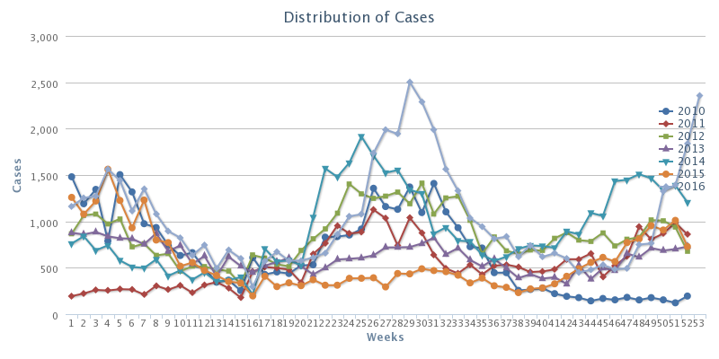

Figure 1.3 Dengue trend for years 2010-2016 in Sri Lanka

Figure 1.4 Dengue case trends from 2000 to 2018 in Sri Lanka

It is very crucial to design and develop a dengue epidemic forecasting model for dengue epidemic as the rate of increase of reported dengue cases in each year since 2005 is alarming.

1.2.2 Dengue Status of Thailand

Thailand reported 6,565 total dengue cases from 75 of the 76 provinces from January 2018 to April 2018. There were nine dengue fatalities. Out of 6,565 total cases, there were 3,878 dengue fever cases, 2,610 dengue hemorrhagic fever and 2 reported deaths and 77 dengue shock syndrome cases and 7 reported deaths. Figure 1.5 shows the dengue trend in Thailand from year 2000 to 2011. Figure 1.6 shows dengue cases by month from year 2000 to 2012. Data displayed on Figure 1.5 and Figure 1.6 are obtained from the survey study presented in [68].

An external file that holds a picture, illustration, etc.
Object name is pntd.0003241.g002.jpg

Figure 1.5 Number of reported dengue disease cases and dengue disease incidence, Thailand, 2000–2011

An external file that holds a picture, illustration, etc.
Object name is pntd.0003241.g006.jpg

Figure 1.6 Number of reported cases of dengue disease, by month, Thailand, 2000–2012

## 1.3 Questions to be Addressed

The proposed solution approaches the dengue mitigation in several directions. Some of them are related to the disease and the others are related to the tools that have been used in the prediction. We also considered investigating influencing factors of the dengue epidemic. The specific questions that we aim to address in this study is given below.

1. what are the factors that affect the spread of dengue epidemic?
2. are there any local factors that are more important when modeling epidemic and missed when considering only global factors?
3. what is the effectiveness of Support Vector Regression (SVR) and micro ensemble architecture in prediction when considering global and local factors with both vector and human population considered? What are the best parameter settings of the SVR?
4. can we improve the result by feeding the SVR and ensemble with a combination of geographical, socio economic, and weather data?

Based on the information presented above, we propose a well formulated computational approach to predict and provide guidance in mitigating dengue epidemic in Sri Lanka and use the same modeling technique to address the dengue burden in Thailand. In the proposed model, we consider all the environmental factors as well as geographical factors that may affect dengue vector population and the reported dengue cases. Contributions of our research proposal are as given below.

## 1.4 Contribution

The contribution of the proposed work is three-fold and span into three major research areas. Those are epidemic analysis, epidemic prediction, and resource allocation. Contribution to each area is explained in detailed below.

1. To provide a comprehensive insight into the dengue epidemic and spread of the vector population based on stimulating factors such as rainfall, temperature, and population density.

The foremost task to be completed before building a framework to identify and mitigate the dengue epidemic is to thoroughly analyze the epidemic. There may be various factors stimulating the spread of the dengue epidemic. These factors may contain directly related factors and hidden factors that are playing a major role in spread of the epidemic. Several major contributors of dengue epidemic have been identified by several research works conducted [1]. Among them, temperature, rainfall, and land use at the top of the list. All the research work conducted so far considered only the global factors and treat every part of the country homogenously. In reality, there is a great variation in climate, land elevation, population, temperature, and rainfall parameters among different regions in two countries. In this study, we consider local parameters and treat each region with different strategy to profoundly represent the state of the particular region throughout the country.

1. To predict the upcoming dengue epidemic and its severity using a support vector regression and micro ensemble architecture.

There are a handful of research projects conducted to find the major stimulating factor of the dengue epidemic. Despite the works that have been done, there is still a lack of dengue mitigation strategy implemented based on the research findings available in Sri Lanka and Thailand. The government of Sri Lanka is deploying numerous projects to mitigate the dengue epidemic. The lack of a method to measure the severity of the epidemic and the failure to identify the epicenter of the epidemic led to failure in the dengue mitigation effort. It is questionable to use global parameters to predict the epidemic acknowledging that each region is different from every other region in terms of population density, rainfall, temperature variation, land use, etc. For the identification of upcoming dengue epidemic, we propose a micro ensemble architecture in which each district is modeled with a small-scale ensemble. The result is obtained by applying a combining strategy on all the results obtained from each output of the ensemble.

1. To allocate limited resources efficiently to effectively mitigate the dengue epidemic

Resources are sparse especially in countries like Sri Lanka and Thailand. It is important to utilize the available resources effectively. This poses a challenge of how to allocate limited resources among facilities which demand for resources. In major outbreaks such as the one happened in year 2017 where all the hospitals over filled with patients, posed a significant threat to patients due to lack of resources. All the resources were lacking including a number of hospital beds during major outbreaks. Resource allocation plan is a major component in response planning. Hence, we proposed a resource allocation strategy based on a modified genetic algorithm (GA). The proposed resource allocation scheme can generate a resource allocation plan in less time compared to the standard GA. The proposed GA is producing a result closer to the optimum.

# Background

The proposed study was evaluated on data sets obtained from Sri Lanka and Thailand. The geographical structure of both countries plays an important role in the variation of climate patterns. Climate pattern is directly related to the spread of the dengue virus. The geography of Sri Lanka and Thailand is described in the following sections.

## 2.1. The Geography of Sri Lanka

Sri Lanka is an island in the Indian Ocean and located in Southern Asia. It has 64,740 km² of land and 870 km² of water. Sri Lanka's climate is tropical. There are two main rainfall seasons which are the northeast monsoon (from December to March), and the southwest monsoon (from June to October). Majority of Sri Lanka’s land is flat at sea level. The highest point is Pidurutalagala which is 2,524.13 m high. Sri Lanka is divided into 9 administrative regions (provinces). Each province is divided into several sub regions (districts) resulting in 25 districts. Administrative regions are shown in Figure 2.1.

|  |  |
| --- | --- |
|  |  |
| (a) | (b) |

Figure 2.1(a) Provinces (b) Districts of Sri Lanka

## 2.2 Rainfall of Sri Lanka

The main sources of rainfall in Sri Lanka are monsoonal, convectional and expressional rain. The mean annual rainfall varies between 900mm to 5,000mm (Figure 2.2).

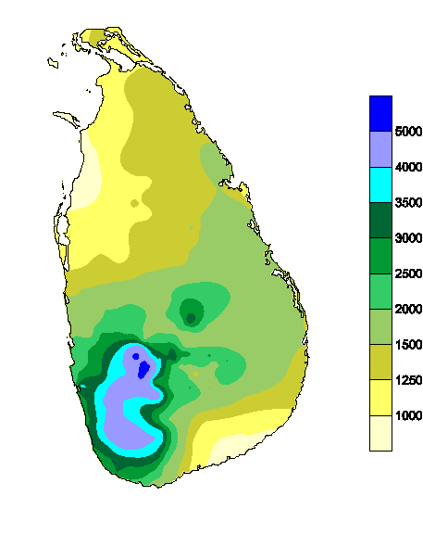

Figure 2.2 **Annual rainfalls in Sri Lanka (Courtesy: Department of Meteorology Sri Lanka)**

## 2.3 Temperature of Sri Lanka

Altitude is the main cause of regional differences observed in air temperature over Sri Lanka. The mean monthly temperatures slightly differ time to time based on the seasonal changes due to movement of the sun. The mean annual temperature in Sri Lanka is rapidly decreasing when moving towards highlands from low lands. At the altitude of 100 m to 150 m, the mean annual temperature is between 26.5 0C to 28.5 0C. The temperature falls rapidly as the altitude increases. The town Nuwara Eliya is at 1,800 m from sea level and its mean annual temperature is 15.9 0C. The coldest month is January, and April and August are the warmest.

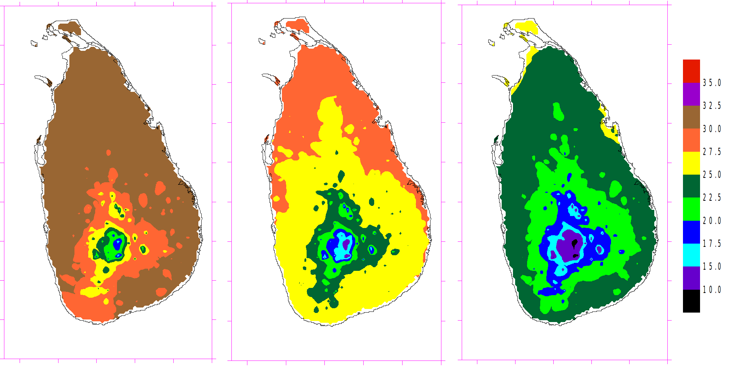

(c)

(b)

(a)

Figure 2.3 Average temperatures from 1961 to 2015 for (a) April (b) August and (c) January **(Courtesy: Department of Meteorology Sri Lanka)**

## 2.4 Climate Seasons of Sri Lanka

The climate experienced for 12 months period in Sri Lanka can be categorized in to four climate seasons. The center part of the country is a mountain range that gives it more than 2500 m elevation from sea level. This sudden change in elevation is the base for having four seasons. The four climate seasons are described below as published by the Department of Meteorology, Sri Lanka [73].

*First Inter-monsoon Season (March - April)*

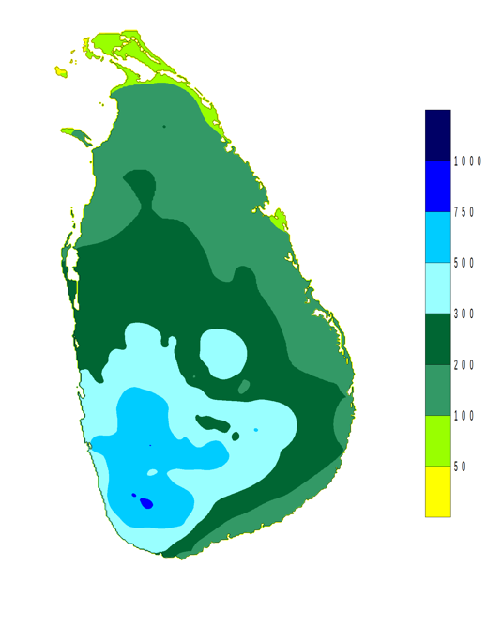

Figure 2.4 Distribution of rainfall in First Inter-monsoon Season **(Courtesy: Department of Meteorology Sri Lanka)**

*Southwest -monsoon Season (May - September)*

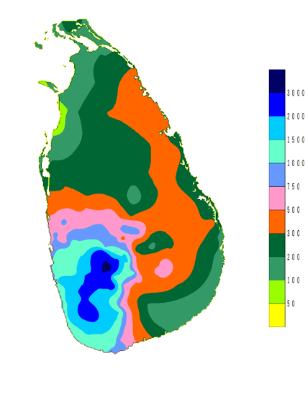

Figure 2.5 rainfall distributions for Southwest -monsoon Season **(Courtesy: Department of Meteorology Sri Lanka)**

*Second Inter-monsoon Season (October-November)*

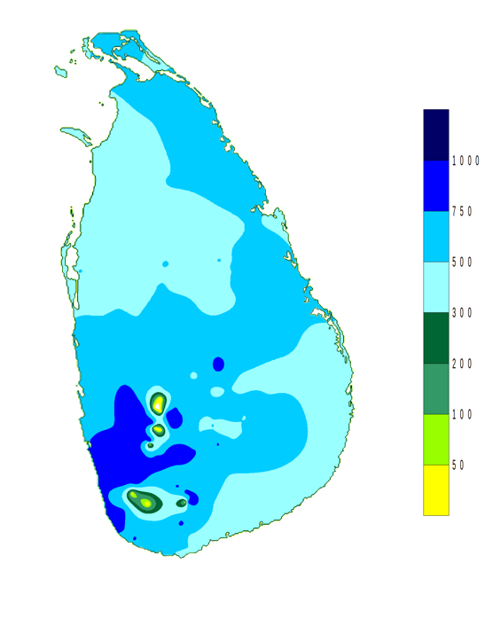

Figure 2.6 rainfall distributions for Second Inter-monsoon Season **(Courtesy: Department of Meteorology Sri Lanka)**

*Northeast -monsoon Season (December - February)*

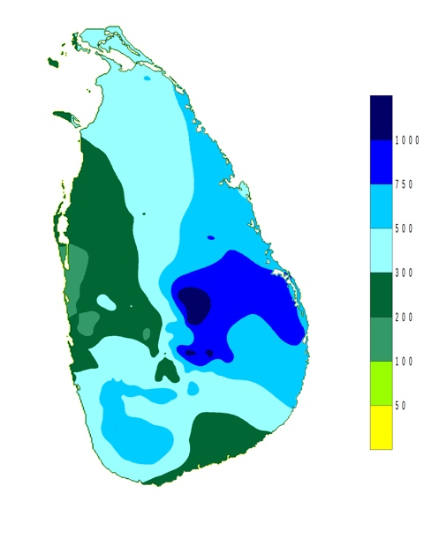

Figure 2.7 rainfall distributions for Northeast -monsoon Season **(Courtesy: Department of Meteorology Sri Lanka)**

## 2.5 The Geography of Thailand

Thailand is located in Southeast Asia. Thailand is the world's 50th-largest country with a total area of 513,000 km2 (198,000 sq mi). Its population ranked the 20th in the world and it is 69 million individuals. Thailand is divided into 76 provinces as given in the Figure 2.8. The 76 provinces are grouped into five larger regions. Bangkok (Krung Thep Maha Nakhon) and Pattaya are considered as two special provinces [74]. Bangkok is considered both a district and a province.

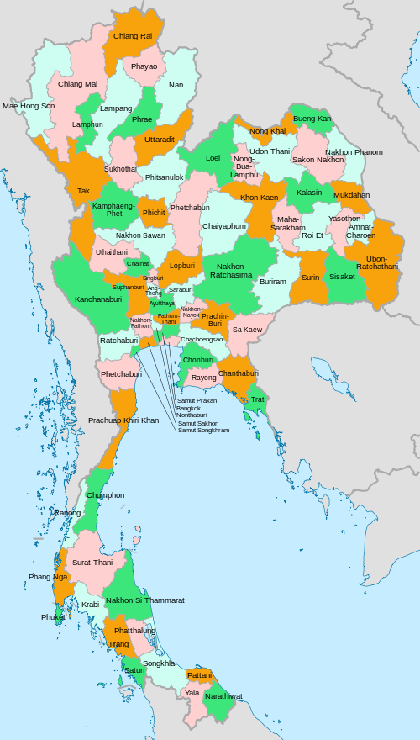

Figure 2.8 Provinces of Thailand (**Courtesy: Wikipedia)**

2.6 The Climate of Thailand

There are three seasons of climate in Thailand [75]. Those are Southwest monsoon season or rainy season (May - October), Northeast monsoon season or Winter season (October - February) and Pre-monsoon season or Summer (February – May).

The five divisions of Thailand are Northern, Northeastern, Central, Eastern and Southern Parts. The rainfall for each part is listed in Table 2.1.

Table 2.1 Seasonal Rainfall (mm) in Thailand

|  |  |  |  |
| --- | --- | --- | --- |
| Region | Winter | Summer | Rainy |
| North | 100.4 | 187.3 | 943.2 |
| Northeast | 76.3 | 224.4 | 1,103.80 |
| Central | 127.3 | 205.4 | 942.5 |
| East | 178.4 | 277.3 | 1,433.20 |
| South |  |  |  |
| - East Coast | 827.9 | 229 | 680 |
| - West Coast | 464.6 | 411.3 | 1,841.30 |

The temperature of Thailand for each part is listed in Table 2.2.

Table 2.2 Temperature (Celsius Degree - °C) in Thailand

|  |  |  |  |  |
| --- | --- | --- | --- | --- |
| Temperature | Region | Winter | Summer | Rainy |
| Mean | North | 23.4 | 28.1 | 27.3 |
|  | Northeast | 24.2 | 28.6 | 27.6 |
|  | Central | 26.2 | 29.7 | 28.2 |
|  | East | 26.7 | 29.1 | 28.3 |
|  | South |  |  |  |
|  | - East Coast | 26.3 | 28.2 | 27.8 |
|  | - West Coast | 27 | 28.4 | 27.5 |

## 3.3 The Dengue Epidemic of Sri Lanka

Dengue virus is a mosquito-borne flavivirus. Dengue existed and has overwhelmed human population for a long period of time. Dengue transmission is supported by the urbanization. Human population growth is another reason for the quick transmission of dengue virus between continents. Specially in the tropical regions of the world, these conditions generated a favorable environment for successful Dengue transmission. *Aedes aegypti* and *Aedes albopictus* are the vectors that transmit DENV among humans. Currently, 48 Aedes species in 11 subgenera have been identified in Sri Lanka. Sri Lanka has been suffered by DF/ DHF epidemics for more than two decades. DF was officially confirmed in Sri Lanka in 1962. In 1966, presence of DF in all major cities in Sri Lanka was confirmed.

Sri Lankan Government targets its control efforts on the disease and vector control, social mobilization, clinical management of DF/DHF patients, and public awareness using media. A president task force on DF/DHF has been established to moderate the DF/DHF control activities. Training professionals to effectively address concerns and intern bringing the DF/DHF mortality to zero, or to a minimum level has also been taken place.

## 3.4 The Virus and the Vector

DENV is a flavivirus which is transmitted by *Aedes* *aegypti* mosquitoes. There are four distinct DENV serotypes, DENV 1–4 [70]. Infection with a single DENV serotype leads to long-term protective immunity against that serotype. The immunity obtained from one serotype will not protect from other serotypes. The geographical distribution of DENV in the world is an indication of the spread of dengue transmitting mosquitos that causes frequent outbreaks [71]. Mosquitoes (female) lay their eggs in water containers such as tires, cans, and in any object that collects water. Rising in the number of dengue cases after rainy seasons directly link to the water requirement of breading of dengue mosquito. The Ae. aegypti mosquito is adapted to urban environments. The Ae. aegypti is abundant in close proximity to humans and causing to have multiple host contacts within short period of time. The female mosquito (female mosquito bites humans and male mosquito does not depend on human blood) bites multiple hosts in order to complete a single meal. DENV infection is replicated in the mosquito midgut and disseminates and replicates in other tissues. Once the DENV infects the salivary glands of the mosquito, it transmits to the host in the next meal of the mosquito [72]. The Aedes mosquitoes are active during the day and protective clothing is recommended where DENV is prominent.

All four serotypes of DENV have been co-existed in Sri Lanka for more than three decades. Despite its long-existence, their distribution has not changed in the last 30 years. Studies found the existence of two or more DENV serotype in different parts of the country. There was an epidemic of DF associated with DENV serotypes 1 and 2 from 1965 to 1968. This island-wide epidemic caused 51 DHF cases and 15 deaths.

## 3.5 REPLAN Framework

RE-PLAN is a computational framework developed to create, analyze and optimize emergency response plans for public health emergencies. Specially, RE-PLAN facilitates the placement of PODs across the region of interest and establishes the geographic region that is being served by each POD. POD locations are selected to minimize the distance that the public has to travel to receive emergency services. Population distribution and geospatial data of the region are utilized for the purpose of response plan creation. Data pertaining to the infrastructure of the region, such as the road network, are utilized in analyzing the effectiveness of the resulting response plan. Specific methods have been developed as part of the RE-PLAN framework to enable creation, analysis and optimization of response plans for different scenarios [2].

A response plan developed in RE-PLAN consists of a set of PODs and their respective service areas. Each POD is a location in the region of interest defined by its geographic coordinates and attributes such as the number of service booths that the facility may accommodate. A service area of a POD is a portion of the region of interest that is serviced by the POD. Service areas consist of groups of contiguous population blocks, which are geographic entities such as represented by polygons with associated population counts. Population blocks, for instance, can be geographic entities such as census blocks or block groups used by the United States Census Bureau to represent populations. RE-PLAN facilitates response plan creation by either establishing the service areas for a set or subset of user-supplied PODs or by recommending a partitioning of the region into service areas and selecting available POD locations for each of the service areas. Methods which determine the service areas for a given set of POD locations are referred to as constrained methods. Unconstrained methods partition the region into service areas and map suitable PODs to these service areas.

The POD placement and determination of catchment areas of RE-PLAN can be used in the mitigation of dengue epidemics. The proposed study is capable of predicting the high-risk areas of the upcoming epidemic. The RE-PLAN framework will be used to place POD facilities in the most needed areas and determine the catchment area of the POD facility. The information generated, such as the population that needs to be served, the total area of the catchment area of the POD facility, from the POD placement can be used in the proposed resource allocation.

# Related work

## 3.1 Dengue Epidemic

There are multiple serotypes involved in increased disease transmission in Asia. The existence of multiple serotypes is also responsible for more frequent outbreaks [8]. There are 2.5 billion people around the world living in dengue-endemic countries with a risk of getting contact with DF/DHF and half of them live in 10 countries of the Southeast Asian region. The Southeast Asian region and the Western Pacific region account for 75% of the global dengue burden. In 2002, DF/DHF was ranked as the third most common noticeable disease in Sri Lanka (first and second were malaria and tuberculosis) [9, 10]. In recent years, deaths due to DF/DHF have been greater than those due to malaria, and DF/DHF is becoming the number one killer mosquito-borne infection in Sri Lanka [9]. At present, DF and DHF are prevalent in many urban and semi-urban areas of Sri Lanka with seasonal and periodic epidemics occurring regularly in the island [5]. In recent decades, a higher incidence of DF/DHF has been reported in the districts of Colombo, Gampaha, Kalutara, Kurunegala, Kegalle, Ratnapura, and Kandy [11]. The reported number of suspected and serologically positive DF/DHF cases, from the epidemic, occurred in 2004, varied from 4,749 to 15,643, involving 25–88 deaths [6]. Jaffna and Batticaloa from northern and eastern provinces respectively reported that DF/ DHF became endemic in those cities with a high dengue incidence [12].

There is a significant relationship between the dengue disease and the age group of the population. In many age groups, males have been affected. According to a regional study conducted by the World Health Organization (WHO) in Sri Lanka. The study was carried out based on reported cases from 1996 to 2005. The proportion of infections of DF/DHF among young male adult aged 15 years was significant. This male dominance was reported in every province of the country. Among those aged 1–4 and 5–14 years, there were significantly fewer male cases than expected, although there was some annual variation [13]. The highest incidence occurred in the 5–9 years age-group [3]. Children population was the main target of DF/DHF before 2000 and young adult was added to the risk list after the year 2000. An increase in mean age affected by DF/DHF was reported. The mean age was increased from 15 to 25 in 1996 to 2006 respectively [4].

Climate change such as temperature, rainfall, and humidity can expand the geographical range of vector mosquitoes. And also, it can extend the length of the disease transmission season. Ideal climate conditions will also reduce the time taken for the virus to get matured and develop into infective stages in mosquitoes. This might increase the propagation rates of diseases transmitted by*A. aegypti and A. albopictus*. In addition, these works clearly pointed out that there is a strong positive correlation between rainfall and the dengue cases reported [7, 14, 15, and 16]. Two DF/DHF peaks occur annually in Sri Lanka. These peaks are in association with the monsoon rains. During peak times, the densities of two mosquito vectors (*A. aegypti and A. albopictus*) are high. The first peak appears in June/July, along with the south-western monsoon that commences in late April. The second peak usually occurs in December and it is associated with the north-eastern monsoon rains (October to December) [3].

Temperature affects DF/DHF outbreaks in many different ways. *A. aegypti* has been shown to transmit DENV when the temperature is above 20 0C. The vector is inactive in temperatures below 16 0C. There is a positive correlation between temperature and the vector growth, especially female vector. And also, the feeding frequency is increased due to the fast reduction of food reserves in mosquitoes in high temperatures [17]. It is predicted that countries that have a mild temperature will have a rapid distribution of DENV due to global warming [18]. This brings serious concerns to temperate countries due to the distribution of *A. albopictus* [19]. Altitude is also a major factor that limits distribution of *A. aegypti*. Lower elevation (less than 500 m) is a favorable location for mosquitoes and hence moderate to heavy mosquito populations are expected. The higher elevation has a low population of mosquitos [20].

There is a couple of researches conducted to study the control measures of the dengue epidemic in Sri Lanka. These studies have revealed couple of strategies to be used in controlling the epidemic. A study conducted in the Kandy District of Sri Lanka showed that the mechanical and biological measures alone are not sufficient to prevent *Aedes* breeding. The prevention of *A. aegypti* and *A. albopictus* breeding in water storage containers would help to control DF/DHF. Therefore, DF/DHF control programs should pay more attention to the control of *Aedes* breeding in domestic water storage containers [5]. More importantly, public education on preventing dengue epidemic will reduce the mosquito breeding sites and hence will be very effective in the dengue mitigation [21, 22]. This will call for a system to integrate all these findings and develop a methodology as proposed in this study to effectively deal with the dengue epidemic in Sri Lanka. We propose to study and use rainfall, temperature, and population density in forecasting/predicting system to clearly identify the high-risk areas. And also, the proposed system is capable of estimating the casualties of the upcoming dengue epidemic and the government officials will be able to prepare for the epidemic. This information will help to educate the general public and to put controlling measures into action.

## 3.2 Forecasting /Prediction

The dengue forecasting/prediction is the process of estimating the number of dengue cases would occur in the future. There are several state-of-the-art techniques to predict dengue cases for a future date. Numerous parameters are being used to model the dengue behavior and used in the prediction. The tools that have been used can be categorized into several major areas. Those include statistical models such as regressions, artificial intelligence models such as Neural Networks, and mathematical models such as Cellular Automata. These research works are briefly summarized in the following section.

### 3.2.1 GIS and Statistical Models

The authors of [23] and [24] studied the prediction of dengue outbreak in Sarawak and Johor respectively by using statistical models. The work presented in [23] analyzes the interaction between environmental, entomological, socio-demographic factors. GIS technology was used to generate geographic and environmental data on *Aedes albopictus* and dengue transmission. A total of 32,838 *Aedes albopictus* eggs were collected from trapping that spans 56 days. Cluster sampling was conducted to determine whether any of the risk factors (entomological or geographical) were influenced by geographical location. SPSS 10.1 was used on the data collected to perform the analysis. Descriptive analysis tools such as frequency, mean, and median were used. Two-sample t-test, and Pearson's Chi-Square were used to determine the association between independent variables and dengue cases reported. Use of differential Global Positioning System in mapping sites of 1m accuracy is also highlighted. Analysis of the data revealed there are major differences in clusters of villages. These differences include the number of *A. albopictus* eggs from ovitraps set indoor, outdoor and in dumping sites, container density, house density, and distance of the house from the main road. T-test conducted showed that the house density, container density, indoor mosquitoes egg count, outdoor mosquitoes egg count, and dumping sites mosquitoes egg count were higher at the roadside villages compared to border villages.

The work presented in [24] links mosquito survival and reproduction with various environmental factors such as rainfall, temperature, living conditions, demography structure domestic waste management and population distribution. A geostatistical method has been used in this study to analyze the correlation between dengue fever, population distribution and climate factors. Authors showed that the spatial variation of dengue incidence can be mapped by combining GIS with geostatistical analysis and space-time permutation scan statistic tools. They support their claim with the fact that Geographically weighted regression (GWR) analysis produced a strong (R2= 0.87) positive spatial correlation between dengue fever and population distribution. Vaidya A. at el. [61] introduces a mathematical, compartmental model to forecast the population dynamics of a mosquito and its life cycle in relation to seasonal variations of temperature and rainfall. Populations within the compartments were expressed in the form of a system of coupled differential equations, which describe changes in the mosquito population through processes of maturation and mortality. By using regression tools, maturation and mortality rates at various temperatures were estimated.

### 3.2.2 Neural Network

A group of researchers had predicted the dengue confirmed cases by using the neural network [32]. The average temperature, average humidity, total rainfall and the number of confirmed dengue cases were used in model training. There are 14,209 dengue cases were used in the training of the model. Authors reported the results are encouraging and the proposed prediction model can be used worldwide. The model was kept time agnostic by eliminating time factors in the model training.

An automatic prediction system of Dengue Hemorrhagic Fever outbreak by using entropy and ANN is proposed in the research study presented in [25]. In this study, authors mandate the information preprocessing prior feeding into ANN. This step will eliminate redundant data and noises. Temperature, relative humidity, and rainfall were considered in the information extraction phase. Then, a supervised neural network was used to predict the possible risk of Dengue Hemorrhagic Fever outbreak. The performance of the proposed system was evaluated based on the experiments conducted with weather data and Dengue Hemorrhagic Fever cases from January 1999 until December 2007. Authors claim 85.92% accuracy.

### 3.2.3 Cellular Automata

Cellular automata models began from the concept of John von Neumann to make the machine copies itself. Cellular means "consist of cells". Cellular automata can be multidimensional. If there are two dimensions, it resembles a checkerboard. Each cell has some adjacent cells and called "Neighborhood". Changing the status of a cell in a one-time step depends on local rules. The local rules may be the probability [35]. This research work uses Moore neighborhood with radius=1 and uses the probability in changing status. The cellular automaton model is used with SIR and SEIR infection propagation models. For SIR model, each cell has only one status in one-time step such as 'S' represents susceptible, 'I' represents infected and is able to transmit the disease to the others, 'R' represents recovered. Some diseases have a latent period, a status for this period is 'E' and is called SEIR model [34]. An outbreak of dengue fever is characterized by a SEIR model. Some people are not sick when exposed to the dengue virus. The patient will have an incubation period of about a week after exposure to the virus and before symptoms to appear. Another study using cellular automata created a model of Hepatitis B Virus (HBV) [31]. The cellular automata (CA) lattice size was 300x5000. The status of a cell in lattice might be "susceptible”, "infected”, "core" or "immune". The local rules were the probability.

A time series model to predict the number of patients with Chickenpox by using Probabilistic Cellular Automata was proposed by a group of researchers [33]. A chromosome of the genetic algorithm consists of the state changing probability. Experimental results showed that the bigger number of cells in the lattice is better than fewer numbers of cells. A different approach is taken in the research work presented in [30]. The proposed model considers the number of people in each status of the epidemic model SIER. In this respect, CA take a Genetic Algorithm (GA) to generate the factor weight chromosomes and ANN to determine the probability of state transition 'S' to 'E' at time step t (Pt (s, e)). In addition, other related probabilities are obtained by expert knowledge; P (e, i) = 0.15 and P (i, s) = 0.001. P (r, s) is determined by GA. These probabilities were used to calculate the cell number of each state at the next time step of GA. GA compute the fitness for one-time step and repeat every time step finally to compute RMSE. For performance evaluation, 32 factors of dengue causes are used in the model. The dataset collected from 2005 to 2011 consisting of 359 weeks in which 287 and 72 are used to train and test the model, respectively. Authors claim, with the results obtained that their method, outperforms the artificial neural network approaches.

### 3.2.4 Support Vector Machine

Support vector machine is used in various fields to perform pattern recognition successfully. These areas include face detection/recognition, object detection, image retrieval, information retrieval, speech recognition, and prediction/forecasting. SVM is also used as a regression model in which a value for the dependent parameter is given instead of the class of the parameter. The aim of many nonlinear forecasting methods [26, 27, 28, and 29] is to predict next points of time series. Tay and Cao [29] proposed C-ascending SVMs by increasing the value of C, the relative importance of the empirical risk with respect to the growth of regularization term. This research assumed, assigning more weights on recent data than distant data results in better performance. C-ascending SVMs produce better results than standard SVM. Fan et al. [28] adopted the SVM approach to the problem of predicting corporate distress from financial statements. In this problem domain, the performance is affected by the choice of input variables. Authors also claimed that selecting suitable input variables has a positive impact on the performance. Input variable must be selected in a way that maximizes the distance of vectors between different classes and minimizes the distance within the same class. Euclidean distance-based input selection generated a better performance.

3.3 Response Planning

Dispensing treatments to the general public during an emergency is an important task. There are numerous works have been done on various aspects of response planning. Every plan must adopt strategies to distribute supplies and dispense medication to the affected population within a specified time frame [36]. There are other important factors such as vulnerabilities of the population must be considered when developing a response plan. Each of these factors is considered separately in different works. Routing and scheduling the distribution of supplies have been addressed in different ways, and management of treatment facilities has been studied. Different strategies to distribute medication among the facilities have been introduced in the research work [37]. Distributing medications and treatment supplies to each local agency is a challenge. The concept of Point of Dispense (PODs) was introduced by the Center for Disease Control (CDC). PODs strategy is been recognized by the authorities as an effective method of planning an emergency. The CDC maintains a warehouse of treatment supplies and medications and delivers them in accordance with the demand to the local authorities. It is the responsibility of each local authority to develop their own response plan adheres to the guideline setup by the CDC [36]. The PODs concept is well utilized in the RE-PLAN framework, developed at the Center for Computational Epidemiology and Response Analysis (CeCERA) [38]. The framework is capable of producing an effective response plan based on PODs placement where necessary. There are couple of different PODs placement methods introduced in the framework. Each of which is suitable for different scenarios. The RE-PLAN is a better candidate for the proposed work, to be integrated with, based on the available features of the RE-PLAN. An additional strain is imposed when dealing with mass events involving mass number of people [39]. Public health and policy studies stressed the mandating the managing of limited resources during an emergency [40]. Ethic that involve in allocating resources during a mass casualty event is presented in [36] [41].

The spatial data of the region is a critical component in response planning. This will allow localization of data and provide a visual feedback to the plan designer. The spatial data may include population distribution and road infrastructure, and census data with arbitrary census blocks. Geographical Information System (GIS) is needed to set up an effective management and manipulation of spatial data. Integration of GIS data and usage of spatial tools in response planning are widely studied and recommended by various studies [42]. RealOpt [43] proposed a simulation and decision support system created to support planning, designing and placing large-scale emergency dispensing clinics for emergency responses. The Centers for Disease Control and Prevention created BioSense, a surveillance system [44], is targeting at early detection of biological emergency events. Coombes [45] and Schneider et al [46] proposed several methods of defining boundaries for the response planning area. The authors proposed algorithms to solve problems associated with discrete and continuous PODs allocation [47, 48, 49, 50, 51 and 52].

3.4 Resource Allocation

Resource allocation is mostly a subpart of response planning for a natural or manmade disaster. There are several research efforts that focused on the optimum allocation of available resources among different entities during disasters. They address different disaster types such as wildfires [64], earthquake [65], and public health emergencies [66].

The research study presented in [64] introduced a minimal stochastic process to model wildfire progression that captures the statistical distribution of fire sizes. The authors then coupled the model to a series of response models that are targeting the measurement of performance of timing and suitability of response plans and also dealing with the distribution of limited resources among multiple entities. The authors proposed to use the framework to compute the optimal strategies for decision-making scenarios. The proposed framework is a set of guidelines and does not involve a method of computation for resource allocation.

A dynamic optimization model can be used in resource allocation [65]. The model was fed with available resources and a detailed description of the concerning areas to calculate the resource performance. In [66], a solution to overwhelming demand for healthcare resource during a large-scale public health emergency was proposed. The authors discussed a resource allocation approach for optimizing regional aid during public health emergencies. They presented a relationship between the optimal response and delaying the distribution of resources from the central stockpile. And also presented that policy level decisions that alter the objectives of pandemic relief efforts can significantly impact the allocations to affected regions. This study is not presenting a computational framework that can be used to allocate resources among facilities.

The agent-based simulations have been using in resource allocations [63]. The authors proposed an agent-based simulation for allocation of resources for a response plan that involved two main facilities. In this study, they try to minimize the hospital arrival times for critically injured casualties. Further, they investigate how the optimal resource allocation depends on the distribution of casualties across the two sites. The author also claimed that this study is tested only on two sites and hence further improvements are needed to apply for a larger number of sites.

I propose a solution to analyze and predict the dengue epidemic with a trained model which considers socio-economical and geographical factors. The main simulating factor for the proposed work is the differences in the administrative regions. Each province has its own geographical and socio-economical characteristics and can be different from each other. Assuming all the provinces are homogeneous may result in a biased conclusion. We need to overcome this shortcoming with the introduction of local characteristics in the model that are specific for each administrative unit. And also, a mechanism, in which the differences in geographical regions is considered, must be integrated into the solution. There is no direct way of feeding geographical differences into the SVR model. I proposed to use micro-ensemble for each province to handle the differences effectively and getting the differences into the model indirectly.

# METHODOLOGY

The methodology of obtaining an efficient prediction system involves multiple steps. These multiple steps include data processing, model generation, model validation and resource allocation etc. The system flow diagram for the proposed study is shown in the Figure 4.1.

Data Acquisition

Data Pre-Analysis

Data Pre-Processing

Model Generation

1. Rainfall, Temperature, Dengue Incidence, Population Data

2. Data Alignment and Cropping

Correlation Analysis

1. Year-wise Data Normalization,

2. Outlier Removal with Iterative Convex Hull Method

1. SVR

2. Least Square Regression

3. K-NN

4. Ensemble (With Best Models)

Model Validation

1. 10-Fold Cross Validation (Prediction)

2. Proposed Accuracy Calculator

Resource Allocation

Proposed Genetic Algorithm

Figure 4.1 Proposed Work-Flow for Dengue Epidemic Mitigation

## 4.1 Data Acquisition

The number of reported dengue cases depends on several factors such as rainfall, temperature, population density, waste management efficiency, land use, and water body management etc. In this study, rainfall, temperature, and population densities are considered in the model generation. These factors are gathered from several sources based on availability. The following sections explain strategies of obtaining each data set.

### 4.1.1 Rainfall Data

The rainfall data was obtained from Global Rainfall Map in Near Real Time (GSMaP_NRT) distributed from the JAXA Global Rainfall Watch, which was developed based on activities of the GSMaP (Global Satellite Mapping of Precipitation) project. The GSMaP project is promoted for the study “Production of a high-precision, high-resolution global precipitation map using satellite data," that is sponsored by the Core Research for Evolutional Science and Technology (CREST) and it is a part of the Japan Science and Technology Agency (JST) [14]. The GSMaP_NRT repository provides hourly rain data in 0.1-degree resolution (10km at the equator). The repository divides the globe into 15 distinct regions as shown in Figure 4.2 and provides the rainfall data separately for each region as Comma Separated Values (CSV) files. The registered users get free access to the repository. The users can obtain data using an FTP client that is connected to the repository using credential provided by the repository management. Thailand is included in the 02_AsiaSE area. Table 4.1 lists location specific information for each Asian region. For the model training, data from five consecutive years was used.

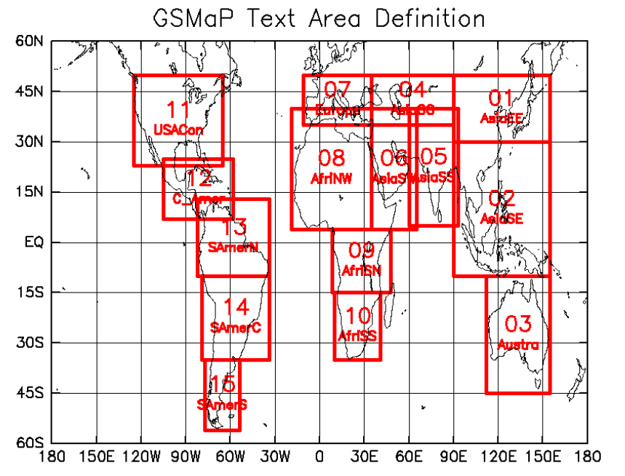

Figure 4.2 Definition of text areas of the JAXA data repository for text data [14]

Table 4.1 GSMap text area declaration for the Asian region [14]

|  |  |  |  |  |  |
| --- | --- | --- | --- | --- | --- |
| **Area name** | **Lon**  **(W)** | **Lon (E)** | **Lat (S)** | **Lat (N)** | **Description** |
| 01_AsiaEE | 90 | 155 | 30 | 50 | East Asia |
| 02_AsiaSE | 90 | 155 | -10 | 30 | South East Asia |
| 04_AsiaCC | 35 | 90 | 35 | 50 | Central Asia |
| 05_AsiaSS | 60 | 93 | 5 | 40 | South Asia |
| 06_AsiaSW | 35 | 65 | 4 | 40 | Arabian Peninsula and East Africa |

### 4.1.2 Temperature Data

Temperature data was obtained from the Thai Meteorological Department (TMD) and the NASA Earth Observations (NEO) data archive [69]. The NEO provides temperature data for the globe at several resolutions. We obtained temperature data points at 0.1-degree resolution for only Thailand’s and Sri Lanka’s regions by applying data preprocessing step. The average temperature value for each month for each district was used in the training. Time span of temperature data is five consecutive years.

### 4.1.3 Dengue Case Data

The Dengue case data for each district for five consecutive years were obtained from Sri Lanka and Thailand Epidemiology Units. Dengue case data is given in three groups which are Dengue Hemorrhagic Fever (DHF), Dengue Fever (DF) and Dengue Shock Syndrome (DSS). We combine all three categories to form a single entity and used in the model training as dengue cases. The Dengue case data was obtained from the Department of Disease Control, Ministry of Health.

### 4.1.4 Population Data

Population data was obtained from the Department of Census from both countries. Census data is not available for each year. We use the same population for consecutive years that follow census year until the next census begins. Population data was divided based on the provinces in Thailand and based on districts in Sri Lanka.

## 4.2 Data Processing

Preprocessing of data is needed as the data sources provide data in different format and at different time and spatial resolutions. The resolution of the temperature data, rainfall data are different. The data portals provide a single data file for the globe and hence a cropping is needed to extract only the relevant data. And also, there are multiple data point in a single province or district, we need to obtain a single figure for each district to be used in the model training. The set of data preprocessing step that we used is described in the following section.

### 4.2.1 Extracting Relevant Data and Alignment of Time Resolution

TheGSMaP_NRT region 02_AsiaSE covers a larger area than Thailand geographical region (Figure 4.2). And the region 05_AsiaSS covers a larger area than Sri Lanka. This results in a large amount of non-related data being loaded into the spatial database making it large that prevents fast computations. To reduce the data load overhead, only the rainfall data that falls inside Thailand’s and Sri Lanka’s geographical areas were obtained by cropping the dataset using longitude and latitude. The non-relevant data was discarded. As the time resolution of rainfall data is one reading per hour, monthly rainfall data was computed from hourly data. This matches the time resolution of each factor before been used in training process as temperature and population data recorded on monthly basis. Further, there are multiple observation points falling in a single province as shown in Figure 4.3. The average accumulated value of all the points that fall in a province was taken as the monthly rainfall of that province. The unit of recording is mm per hour(mm/hr). A sample file of rainfall data from the GSMaP_NRT is shown in the Table 4.2.

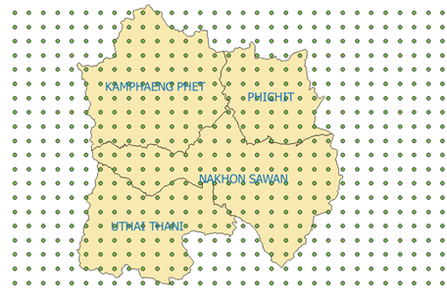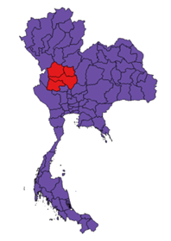

Figure 4.3 Rain fall data observation points and geographical boundaries of all four provinces

Table 4.2 Fragment of rainfall data text file from GSMap_NRT

|  |  |  |
| --- | --- | --- |
| **Lat** | **Lon** | **RainRate** |
| 20.95 | 97.05 | 0.1 |
| 20.85 | 97.05 | 0.06 |
| 20.75 | 97.05 | 0.04 |
| 20.65 | 97.05 | 0.06 |

## 4.3 Pre-analysis of Data

The proposed model to be used in this study is the SVR [15] and Ensemble. The SVR is built on regression model. To get a better result from a regression analysis, there must be a positive correlation between explanatory variables (factors) and dependent variable (dengue incidence). As the primary model of prediction is SVR, this study requires data analysis before moving forward with the SVR. A separate correlation analysis was conducted for each factor (rain, temperature and population) to determine the suitability of the regression analysis of the proposed factors. Correlation is a statistical relationship between those two sets of data which describes the strength of the relationship between those two data sets. If the correlation is low, there is a weak interdependency between those two sets. If the correlation is high (normally greater than 0.5 negative or positive), there is a considerable relationship between those two sets. Correlation of two data sets is computed as shown in the equation below.

$ρ_{X, Y}=\frac{E[\left(X-μX\right)\left(Y-μY\right)]}{σXσY}$ (1)

Where $ρ_{X, Y}$ is the correlation between datasets X and Y. E is the expected value operator. $μX$ is the mean of data set X, $μY$ is the mean of data set Y. $σX$ and $σY$ are standard deviation of data sets X and Y respectively. The correlation value is interpreted as shown in Table 4.3.

Table 4.3 Correlation values and their meanings

|  |  |
| --- | --- |
| Correlation Value | Interpretation |
| -1 | A perfect downhill (negative) linear relationship |
| -0.7 | A strong downhill (negative) linear relationship |
| -0.5 | A moderate downhill (negative) relationship |
| -0.3 | A weak downhill (negative) linear relationship |
| 0 | No linear relationship |
| +0.3 | A weak uphill (positive) linear relationship |
| +0.5 | A moderate uphill (positive) relationship |
| +0.7 | A strong uphill (positive) linear relationship |
| +1 | A perfect uphill (positive) linear relationship |

## 4.4 Pre-processing of Data

The data needed for the proposed study obtained from different types of resources. The possibility of having errors in thee data sets is high. The rainfall data is obtained from a remote sensing data repository recorded using a satellite. The existence of missing data in the dataset is more likely. The dengue incidence is reported by human. The chance of having errors in the dengue incidence is high. There must be data pre-processing steps to eliminate or reduce the effect of incorrect data on the prediction results.

### 4.4.1 Yearly Data Normalization to Eliminate Year Specific Influences

The rainfall pattern for each province is a recurrent pattern that has little variation from the average rainfall data for the year. Dengue incidences are varying from year to year due to various reasons such as flooding, droughts, waste management deficiencies, etc. Dengue case data has a constant and strong correlation to the rainfall data. The correlation of the rainfall data is specific to the reference year and does not stay the same for every year in general due to various other influencing factors mentioned above. There may be a boost or a decline in the number of cases due to some other influences such as temperature, special environmental events such as flood and droughts, etc. The rainfall pattern along with dengue incidence for the province Amnat Chareon is shown in the Figure 4.4 for six years starting from 2012. This variation is not cooperating well with machine learning tools especially with regression tools. Therefore, we use yearly normalization to eliminate or to reduce the impact of the afore mentioned effects from the rainfall and dengue incidences. The normalized dengue incidence pattern along with the rainfall data for the province Amnat Chareon is shown in the Figure 4.5.

Figure 4.4 Monthly Rainfall and Incidence Data for Six Years from 2010

Figure 4.5 Normalized Monthly Rainfall and Incidence Data for Six Years from 2010

### 4.4.2 Outlier Removal

The Dengue case data may be reported to the authorities partially. If the data reported is partial, the relationship between influencing factors and dengue cases is not clearly observable. It is critical to identify these instances in advance and treat them properly to ensure the quality of the generated predictive model. These unusual instances are known as outliers. We proposed a method of outlier removal in which a convex hull is used to determine the outliers. This method uses the fact that the outliers (extreme points) located further away from the main cluster of data points. The extreme outliers weaken the correlation of the reported dengue incidence and the rainfall data. This technique is shown in the Figure 4.6.

.

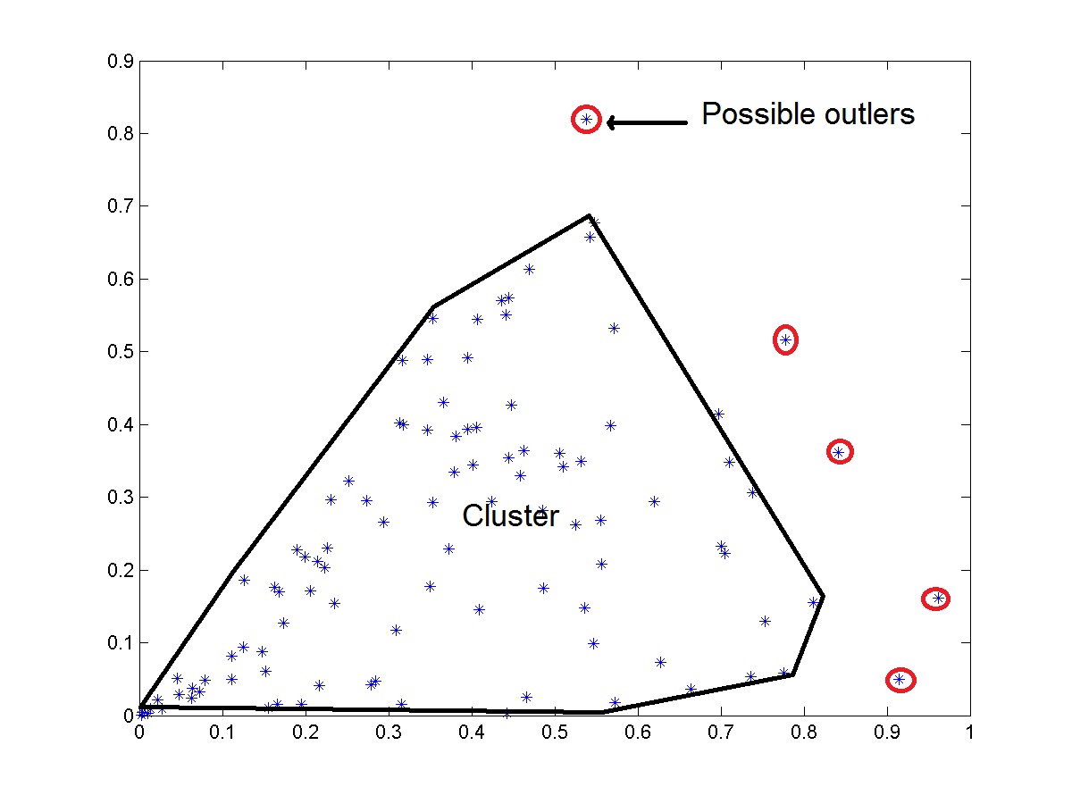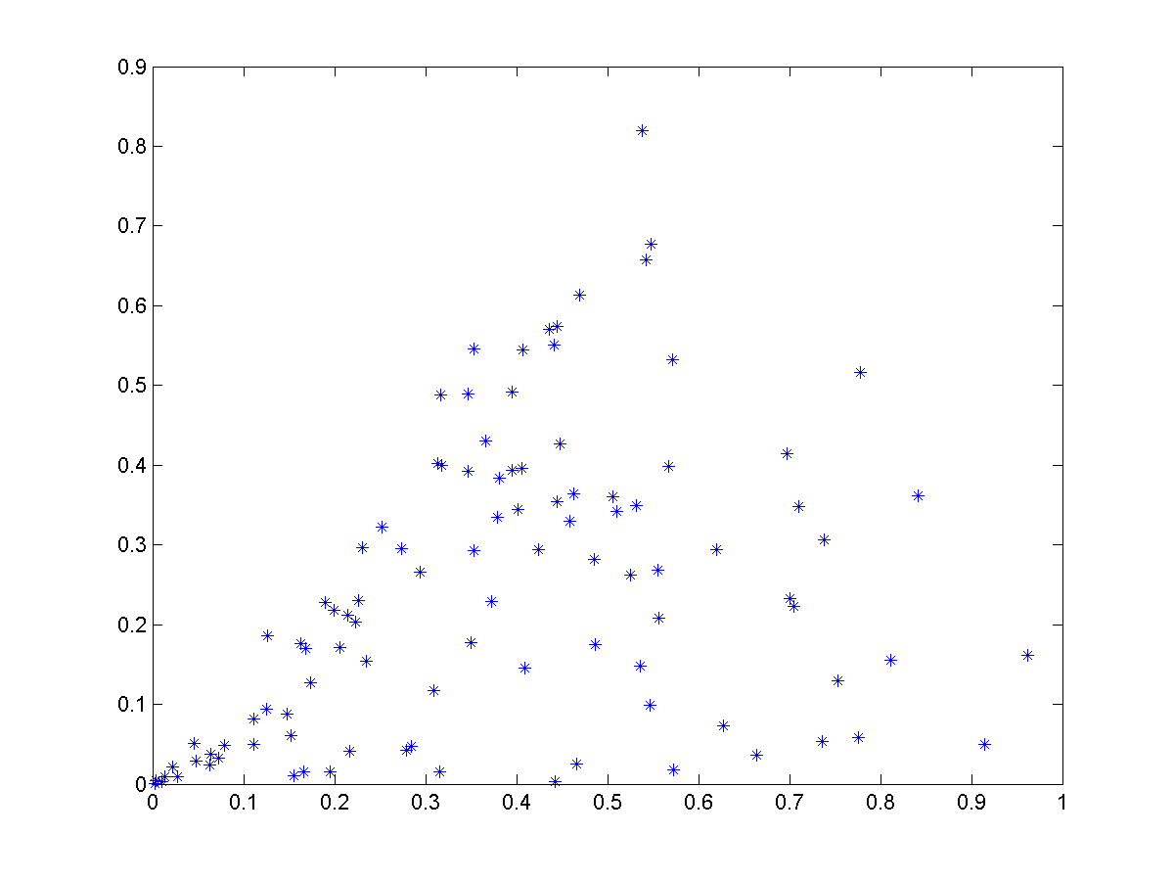

Figure 4.6 Outliers in Data Points

The proposed method operates in two stages, which are identification of the presence of an outlier and removal of identified outlier. In the first stage, a convex hull is generated for the projection of each influencing factor to the dengue incidence in 2-dimensional Cartesian coordinate system. This stage is shown in the Figure 4.7.

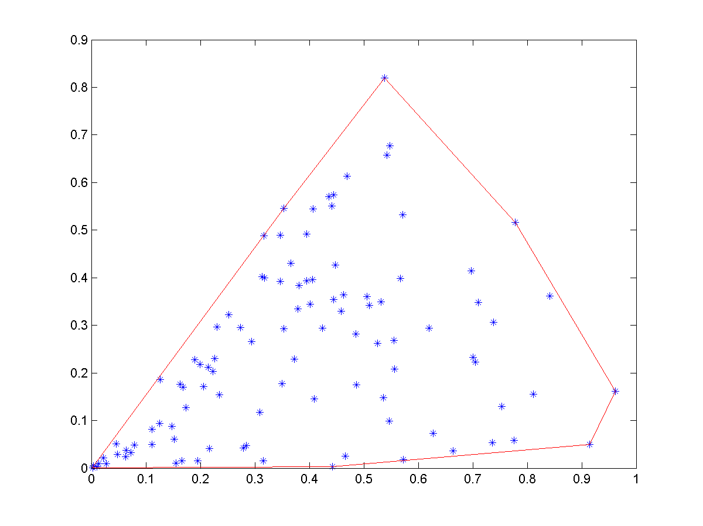

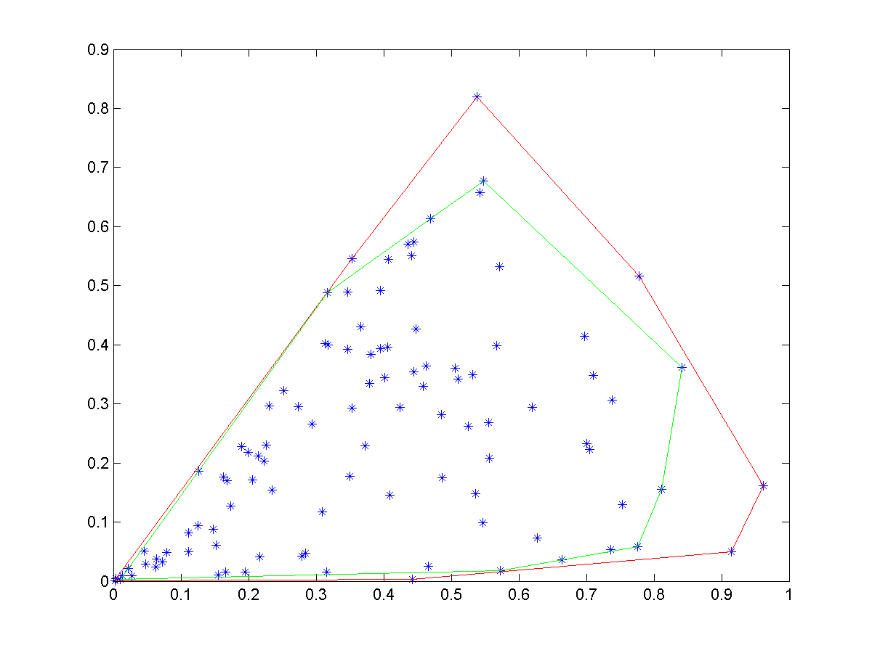

Figure 4.7 Outlier Removal Levels

4.4.2.1 Iterative Convex Hull Reduction to Remove Outliers

The outlier removal takes place as an iterative process. First, the convex hull of the two-dimensional dataset is generated. The area of the outer most convex hull is computed. In the next iteration, the points that formed the convex hull are removed from the original data set and regenerate the convex hull for the remaining points. We then compute the difference in areas of the convex hull generated from the previous iteration to the current iteration. Iteration stops if the difference in areas is below a predetermined threshold value or preset number of maximum iterations reached. A significant difference in areas indicates the presence of an outlier and hence need to determine the outlier point from the set of convex hull points.

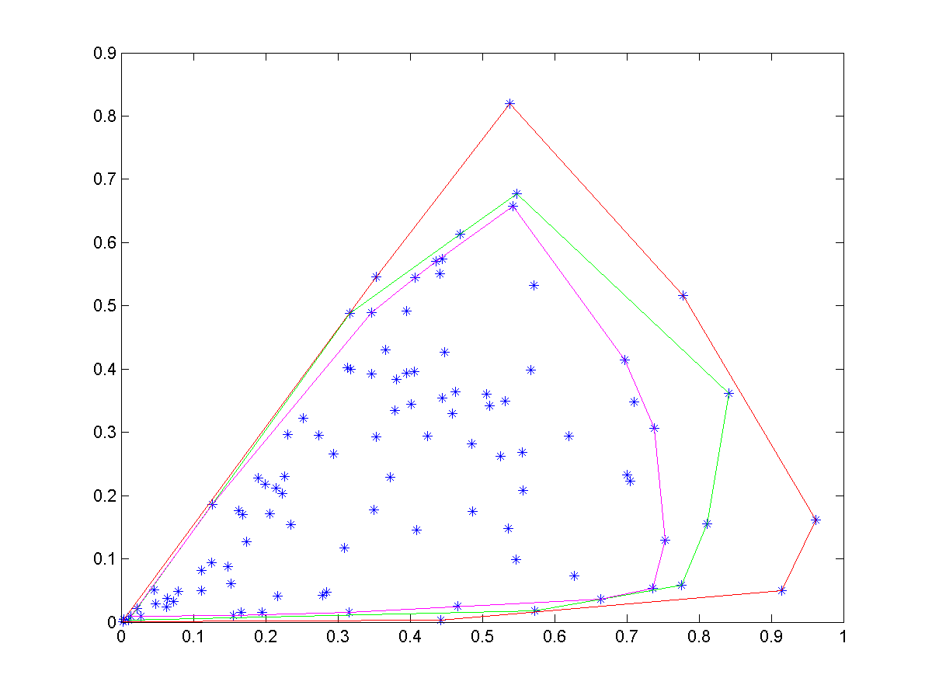Figure 4.8 Three Levels of Outlier Removals



Let ΔA is the difference in area between two iterations.

$$∆A=|{A\left(ConvexHull\right)}_{i}- {A\left(ConvexHull\right)}_{i-1}|$$

4.4.2.1 Determination of Points to be Removed from Outer Convex Hull in the Presence of Outliers

Once the presence of the outliers detected, the next step is to identify the exact outliers from the points of outer convex hull. All the points that form the convex hull are not always outliers. A subset of the points of the convex hull is outliers. An exhaustive search is performed to identify the outliers among the points on the outer convex hull. The difference in surface area is computed keeping one point of the convex hull out. All the points that generate a difference in area greater than or equal to a predetermine threshold value are classified as outliers. All the remaining points of the convex hull kept in the dataset as not outliers.

## 4.5 Model Generation

The model generation is performed on the processed data sets that went through pre-analysis and pre-processing steps. The data set is divided into two parts and used in model generation and model validations steps. The model generation steps are described in the following sections. The SVR, LS and KNN are trained with the data sets.

### 4.5.1 Support Vector Regression

The behavior of each factor (rainfall, temperature, and population density) on dengue cases is spatially dependent. The effect of rainfall on dengue incidence for each district is different from district to district as emphasized in [5]. Hence, a separate analysis for each district was conducted and a separate model for each province was generated. Data for five years were combined for each district and used in the model generation. The proposed arrangement can capture the spatial heterogeneity of each province and hence improve the performance of the prediction model.

The SVR model is based on the regression analysis. A regression analysis can estimate the relationship between two data sets (random variable) and fit a cure to the data sets (explanatory variable and dependent variable). This curve can then be used in prediction of unknown cases. The regression curve for this study has three explanatory variables, Rain R, Population P, and Temperature T. The regression model for this study is shown in the equation below.

$C_{di}= β_{0}+ β_{1}P_{i}+ β_{2}R_{i}+ β_{3}T_{i}+ ε$ (2)

Where Pi is the population in *i*th region, Ri is the rainfall for *i*th region and $T_{i}$ is the temperature for *i*th region. The error term is $ε$. $C_{di}$ is the dengue cases for region *i*. Intercept is $β_{0}$ and it is a constant.

SVR improves the detection speed as it keeps only a subset of training data as support vectors in the model. The SVR uses the same principles as the Support Vector Machine (SVM) for classification, with only a few minor differences. SVR’s output is a real number which makes it difficult to perform one to one matching with the test dataset. A margin of tolerance (epsilon) is set in approximation to the SVM to address the problem associated with real numbers output.  General construction of SVR is given in the following equations.

SVM regression is constructed by first mapping the input vector X into an m-dimensional feature space using a non-linear mapping function. The linear regression model is then constructed in this feature space. The linear model $f\left(x,ω\right)$  is given by equation 3.

$f\left(x,ω\right)= \sum_{j=1}^{m}{w_{j}g_{j}\left(x\right)+b}$   (3)

Where $g_{j}\left(x\right) , j=1,…m$  denotes a set of nonlinear transformations and b is the “bias” term. The bias term can be dropped with the assumption of a normal distribution in the data set. $ω$ is the normal vector.

The quality of estimation is measured by the loss function $L_{ε }\left(y, f\left(x, ω\right)\right)$ tha tis shown in the equation 4. The loss function is computed as proposed in [16]. If the estimated value is falling between two bands of width $ε$, the estimation function is considered as appropriate. If the estimated values are falling outside the above-mentioned band, it is considered as a loss. The amount of loss is computed as shown in equation 4. These loss values are accumulated and hence needed to be minimized to get a better estimation function. The lower the loss value the better the estimation function is.

$L_{ε }\left(y, f\left(x, ω\right)\right)= \left\{\begin{matrix}0 if \left| y- f\left(x, ω\right)\right|≤ ε \\ \left|y- f\left(x, ω\right)\right|- ε otherwise\end{matrix}\right.$ (4)

The empirical risk function is given in equation 5. The empirical risk ( $R_{emp})$ is the total amount of loss of the estimation function. This value is computed as the summation of all the loss values computed for all the points in the training data set.

$R_{emp}\left(ω\right)= \frac{1}{n}\sum_{i=1}^{n}{L_{ε }\left(y, f\left(x, ω\right)\right)}$           (5)

The model is generated by minimizing the ${\left\|ω\right\|}^{2}$. This can be achieved by introducing (non-negative) slack variables $ξ_{i}, ξ_{i}^{*} i=1,…n$ to measure the deviation of training samples outside http://kernelsvm.tripod.com/index_files/image032.gif-insensitive zone. Thus, the SVM regression is formulated by minimization of the function shown in the equation 6.

${\arg{min⁡}}_{(ω)}= \frac{1}{2}{\left\|ω\right\|}^{2}+C\sum_{i=1}^{n}{(ξ_{i}+ξ_{i}^{*})}$ (6)

Such that $\left\{\begin{matrix}y_{i}- f\left(x_{i}, ω\right) ≤ ε+ξ_{i}^{*} \\ f\left(x_{i}, ω\right)- y_{i} ≤ ε+ξ_{i} \\ ξ_{i} , ξ_{i}^{*}≥0, i=1,…,n\end{matrix}\right.$

The estimation function is determined by optimizing the loss function to have a minimum loss for all the training data sets. This optimization problem can be transformed into the dual problem and its solution is given by the equation in 7.

$f\left(x\right)= \sum_{i=1}^{n_{sv}}{(α_{i}-α_{i}^{*})K(x_{i},x)}$ (7)

Such that: $0 ≤ α_{i}^{*} ≤C, 0 ≤ α_{i}≤C$

Where $n_{sv}$ is the number of Support Vectors (SVs) and the kernel function is given by the equation in 8.

$K\left(x_{i},x\right)=\sum_{j=1}^{m}{g_{j}(x)g_{j}(x_{i})}$  (8)

The Radial Basis Function (RBF) was used as the kernel function and epsilon was set to 0.001. The cost parameter c was kept at 100.

### 4.5.2 k-Nearest Neighbor Regression

The k-nearest neighbor (k-NN) Regression is a conventional non-parametric classifier [67]. The k-NN classifier calculates the distances between the testing point and points in the training data set. To measure the distance between points A and B in a feature space, various distance functions have been used in the literature, in which the Euclidean distance function is the most widely used one. k is an integer. The value selected for k has a direct impact of the predicted value and hence must be carefully selected for the problem domain. For this study, Euclidean distance was the distance metric and number of neighbors was three. The final predicted value is the average of k nearest neighbors.

Let A and B are represented by feature vectors A = (x1, x2, …, xm) and B = (y1, y2, …, ym), where m is the dimensionality of the feature space. To calculate the distance between A and B, the normalized Euclidean metric is used by

$dist\left(A, B\right)= \sqrt{\frac{\sum_{i=1}^{m}{{(x_{i}-y_{i})}^{2}}}{m}}$ (9)

k-NN performs better in many problem domains. The accuracy of the k-NN is high and used often in the literature. We used the k-NN as the base predictor and compare the SVR and LS against the k-NN.

### 4.5.3 Least Square Regression

The linear least squares regression is a widely used modeling method. It is also referred to as regression, linear regression or least squares. linear least squares regression can be used to fit the data with a function of the form

$y= β0+β1x1+β2x2+… βnxn$ (10)

in which

1. each explanatory variable in the function is multiplied by a coefficient
2. there is one constant
3. all terms are summed to form the final function

Error minimization is done as the same way as SVR. The only difference is the way the model is generated. In SVR it uses support vectors to keep the model parameters.

## 4.6 Prediction

The model generation is done on the past data of rainfall, temperature and population density. Three regressors are trained with the past data, SVR, LS and k-NN. An ensemble of regressors are built from these three regressors for each district. The future climate data and population densities are used to estimate the dengue incidence that would occur in the future. If the forecasted climate and population data is accurate the prediction is also accurate. The latest technologies used in the meteorological context is capable of closely estimating the future climate data. The predicted dengue incidence can be used to determine the severity of the epidemic that may occur if the given scenario appears in the future. The forecasted climate data may differ from the past climate data. The generalized and properly generated SVR, LS and k-NN is capable of correctly predicting the dengue incidence for even unseen climate data. That is the main advantage of using regressors in prediction.

## 4.7 Model Validation

Conventional regression models are evaluated based on the Mean Square Error (MSE) of the cross validation (mostly 10-fold cross validation). MSE cannot capture the total picture of the behavior of the data set. Several outliers in the data sets can affect the final outcome of the validation. Another problem of regression analysis is there is no way of computing the accuracy of the prediction with cross validation as the accuracy is computed based on the classification with class labels. Regressors’ outputs are real numbers whereas classifiers’ outputs are class labels. The method of validating regressors is the Mean Square Error (MSE) or adjusted R2 value.

In this study a novel yet, simple accuracy calculation method was introduced. A positive confidence boundary parameter α was included in cross validation. If *|actual value – estimated value| > α*, we label the estimated value as a correct prediction and incorrect prediction otherwise. The proposed accuracy calculation is shown in the Figure 4.9.

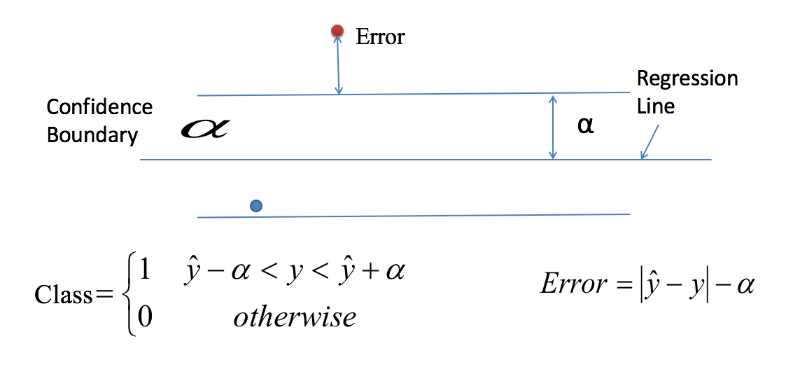

Figure 4.9 Accuracy Calculation of SVR

Accuracy is calculated according to the equation given below.

$ACC=\frac{Number of correct predictions}{Total number of predictions}$ (11)

### 4.7.1 Determination of the Degree of Fit of the Regression Model to the Dataset with Parameter Alpha (α).

The parameter *α* is the width of the confidence boundary. The larger the boundary the better the accuracy. The selection of the *α* determine the validity of the regressor for the problem domain. The value of *α* is inversely proportional to the model accuracy. If the model generates a higher accuracy value for a lower value of *α,* the regression model fits well to the dataset as the confidence boundaries are narrow. If the accuracy is high for narrow band of confidence, the majority of the training data points fall inside the narrow band. If the model accuracy is high only for a large value of *α, the* dataset is loosely correlated to the influencing factors as the spread of the data set is high. Higher accuracy for a smaller alpha value indicates that the dataset and the fitted regression is a best fit for the problem domain. The target of the proposed study was to achieve a high accuracy for a smaller *α value. The* *α value used in this study was 0.2.*

### 4.7.2 10—Fold Cross Validation

Cross-validation is a model validation technique for assessing how the results of an analysis will generalize to the underlying population of the extracted data set. It is used in predictions to evaluate the outcome of the model. In a prediction problem, a model usually has access to a training dataset with known outcome values, and a dataset of unknown outcome data. The goal of the cross-validation is to test the model’s ability to predict new data that was not used in training stage of the model. In this study, we used 10-fold cross validation where dataset is divided into 10 subsets. One portion is kept as the testing data set and nine portions are used in the training. This process is repeated 10 times alternating the testing portion from the initial division. Final outcome of the model is obtained averaging the 10 outputs of the process.

## 4.8 Resource Allocation

A successful dengue mitigation plan must include an effective resource allocation scheme. The mitigation plan must allocate resources such as medications, professionals (doctors, nurses, and healthcare workers), and vector control chemicals. In this study, we designed the resource allocation algorithm to accommodate desired number of different kinds of resources and the algorithm will extend to facilitate the allocation. An effective resource allocation should eliminate wastage of resource, over allocation and under allocation of resources while satisfying the demand of each facility for a given resource. Over allocating may result in run out of available resources before every demand is satisfied. Under allocating may result in failure of mitigation plan. Hence, an effective resource allocation is needed to ensure a proper distribution of available resources among facilities to satisfy their demands.

### 4.8.1 Problem Definition

Let F1,F2….Fn is the set of facilities demanding for resources R1, R2,……Rm with a demand for each resource W00, W01,…….Wnm. with the constraint $W_{ij}∈ R [0,m]$. As the available resources may not be sufficient to fulfill the demand of each facility, the allocation algorithm must generate an optimum allocation that minimizes the penalty of allocating less than the demanded resources. The final allocated scheme is represented as A00, A01,…..Anm. This problem can be modeled as a bi-partite matching between facilities and resources with a weight of each mapping as the demand. We represent this problem using a bi-partite grape as shown in the Figure 4.10.

### 4.8.2 Problem Representation

The problem of resource allocation with demand can be successfully represented with a bi-partite graph. The graph is constructed with resources and facilities as two sides and demand as weight of associations. The graphical representation can be seen in Figure 4.10. In the figure resources are represented with R0…Rm, facilities are represented with F0,…Fn and corresponding demands are represented with W00,…..Wnm.

F1

Fn

Rm

Rm

W02

Wij

Figure 4.10 Bi-Partite Graph of Resource Mapping

### 4.8.3 Digital Representation

The resource allocation problem is represented as an adjacency matrix that is algorithm friendly. The resources are arranged along x axis and the facilities are arranged along y axis. Weight (demand) of the matching is the corresponding element of the matrix.

Demand of resources

F1

.

.

Fn

R1 . … … … Rm

$\left[\begin{matrix}W_{00} & W_{01} & W_{0m} \\ ⋮ & ⋮ & ⋮ \\ W_{n0} & W_{n1} & W_{nm}\end{matrix}\right]$

Allocation of resources

R1 . … … … Rm

F1

.

.

Fn

$\left[\begin{matrix}A_{00} & { A}_{01} & A_{0m} \\ ⋮ & ⋮ & ⋮ \\ A_{n0} & A_{n1} & A_{nm}\end{matrix}\right]$

### 4.8.4 Finding the Optimum Solution for Resource Allocation Problem

The best allocation is to deliver each facility the resources they requested. The scarcity of resources prevents us from delivering the requested amount of resources for all the facilities. The goal is to find the optimum resource allocation that will minimize the impact of being delivered below the demanding amount. This requires an efficient and effective method of calculating the impact of resource allocation on each facility. We propose to calculate a penalty score for each facility based on its important properties. The severity of allocating fewer resources than demanded is depended on the population that needed to be served and surface area of the serving region. The penalty score is calculated according to the equation given below.

$$Penalty Score= \left|W_{ij}\left(Allocated\right)- W_{ij}(Demand)\right|*{Population}_{i}*{area}_{i}*{risk}_{i}$$

The goal of the minimization algorithm is to minimize the total penalty score which is given in the equation below.

$$Total Penalty Score=\sum_{i=0,j=0}^{i=n,j=m}{\left|W_{ij}\left(Allocated\right)- W_{ij}(Demand)\right|*{Population}_{i}*{area}_{i}}*{risk}_{i}$$

### 4.8.5 Weight Adjustments

The best approach is to use exhaustive search to look for the best match for weight for allocated matrix. The number of candidates in the exhaustive search space is increased exponentially with the number of facilities and number of available resource categories. The exhaustive search is computationally expensive and is therefore not an ideal candidate to find weights of the allocated matrix. We propose to use Genetic Algorithm approach with several modifications to match the problem domain.

Genetic Algorithm can be successfully applied in searching for a best fit from large number of candidate solutions. The GA performs best when the available number of candidates is high. State of the art GA is defined as follows. The genetic algorithm is an optimization technique built on the principle of genetics and natural selection. The GA comes under the category of machine learning. Given a set of possible solutions to the given problem, the GA tries to select the best match based on the criteria set in advance. The GA selects a subset of population that meets the given criteria. This subset undergoes two steps, namely crossover and mutation, producing new children similar to natural process of selecting best fit candidates. This process is repeated over several iterations. Each candidate solution is assigned a fitness value and the fitter individuals are given a higher chance to mate and yield more “fitter” individuals.

The GA is randomized in nature when selecting crossover points and mutation points. The randomness in crossover and mutation is not applicable in the problem domain of dengue mitigation. We introduce a variant of crossover and mutation such that the resulting off springs are compliance with the requirements of the resource allocation.

We propose several major modifications to the standard GA for achieving optimum results for the resource allocation problem. These modifications are generalized and can be applied to any resource allocation problem. The modifications are listed below.

1. a new chromosome representation for resource allocation
2. modify the way the standard GA generates the initial population.
3. modify the way the standard GA does crossover operation
4. modify the way the standard GA does mutation
   1. a new concept of resource lock chromosome
   2. a novel sliding mutation scheme to accelerate the convergence
5. modify the iteration of the GA to accommodate sliding mutation scheme

All the above stages are detailed in the following sections.

### 4.8.6 The GA Representation of the Problem

The problem of allocating set of resources among set of facilities must be represented in a single string of genes called a chromosome. We select decimal numbers in each location of gene as oppose to binary digits in the standard GA. The binary chromosome and the proposed chromosome are shown in the Figure 4.11 below.

The standard binary chromosome

|  |  |  |  |  |  |  |  |  |  |
| --- | --- | --- | --- | --- | --- | --- | --- | --- | --- |
| 1 | 1 | 0 | 0 | 0 | 1 | 0 | 1 | 1 | 0 |

Gene Boundary for Facility 1

The proposed chromosome

|  |  |  |  |  |  |  |  |  |  |
| --- | --- | --- | --- | --- | --- | --- | --- | --- | --- |
| W11 | W12 | .. | W1m | .. | .. | Wn1 | Wn2 | .. | Wnm |

Figure 4.11 The Modified Chromosome for Genetic Algorithm

The resources for a given facility must be placed in adjacent genes of the chromosome. Gene boundary is used here after throughout the document as to represent the set of resources for a given facility.

Resource allocation requirements that must be embedded in GA are given below.

* Total number of allocated resources must match the total number of available resources when performing mutations.
* The Gene Boundary must not be broken apart when performing crossovers.

### 4.8.7 Proposed Population Generation Procedure

As opposed to the standard GA we use a customized population generation technique. In the proposed scheme, a constraint is set forth and eliminates chromosomes that violate the constraint. All the resulting chromosomes allocate resources that are under the limits of availability of resources. The constraint is modeled as shown in equation below. The number of facilities is n and number of resources is m.

$$Allocated Amount of Resource\left(i\right)=\sum_{j=1}^{n}{A_{ji}} :1≤i≤m$$

Constraint -> $Allocated Amount of Resource \left(i\right)$ $≤$ Available amount of resources (i)

### 4.8.8 Proposed Crossover Operation

The crossovers are performed such that the gene boundaries are preserved. A gene boundary is treated as a single entity in crossover and hence the problem reduced to binary crossover in standard GA. A sample crossover is shown in Figure 4.12.

Chromosome 1

|  |  |  |  |  |  |  |  |  |  |
| --- | --- | --- | --- | --- | --- | --- | --- | --- | --- |
| W11 | W12 | .. | W1m | .. | .. | Wn1 | Wn2 | .. | Wnm |

Crossover point

Chromosome 2

|  |  |  |  |  |  |  |  |  |  |
| --- | --- | --- | --- | --- | --- | --- | --- | --- | --- |
| W11 | W12 | .. | W1m | .. | .. | Wn1 | Wn2 | .. | Wnm |

Resulting Chromosomes

|  |  |  |  |  |  |  |  |  |  |
| --- | --- | --- | --- | --- | --- | --- | --- | --- | --- |
| W11 | W12 | .. | W1m | .. | .. | Wn1 | Wn2 | .. | Wnm |

|  |  |  |  |  |  |  |  |  |  |
| --- | --- | --- | --- | --- | --- | --- | --- | --- | --- |
| W11 | W12 | .. | W1m | .. | .. | Wn1 | Wn2 | .. | Wnm |

Figure 4.12 Proposed Cross-Over Operation

### 4.8.9 Proposed Mutation Operation

The proposed mutation operation selects number of mutation points based on the mutation rate as the standard GA. The chromosome generated after each operation, mutation and crossover, must satisfy the constraints of the problem domain. For instance, the amount of total allocated resource s must not exceed the available amount of resources. This is in contrast to the standard GA where it selects random points based on the mutation rate and mutate the bit regardless of the prior domain knowledge. In the proposed mutation operation, if the resulting chromosome demands more resources than available amount of resources after mutation it is not considered a good fit. A random mutation is not suitable in the proposed problem domain.

The algorithm randomly picks a resource type from the list of available resources. Next, a set of facilities are randomly selected to apply the mutation operation on the selected resource from the first step. A resource exchange operation takes place between selected facilities for randomly selected resource type. This will make sure that the allocated amount of resources is not exceeding the available amount of resources. The proposed mutation operation is shown in Figure 4.13. Let the mutation operation randomly picked facility 1 and facility n for resource exchanging. All the other facilities remain unchanged and resource type 1(Wi1) was randomly selected for mutation.

Chromosome 1

|  |  |  |  |  |  |  |  |  |  |
| --- | --- | --- | --- | --- | --- | --- | --- | --- | --- |
| W11 | W12 | .. | W1m | .. | .. | Wn1 | Wn2 | .. | Wnm |

Facility 1 Facility n

Mutation -> W11 = W11 – a Mutation -> Wn1 = Wn1 + a

Figure 4.13 The Proposed Mutation Operation

### 4.8.10 Fitness function

The fitness function is modeled as a function of risk associated with the given facility based on the location of the facility, population count of the facility, amount of area to be served by the facility. The proposed method of fitness calculation will guarantee that resources are allocated appropriately. The final fitness value is computed for all the facilities (from facility Fi=0 to n) for all the resources (from resource Rj=0 to m) together as shown in the equation below.

$$Final risk value= \sum_{i=0}^{n}{\sum_{j=0}^{m}{{|R_{j}\left(allocated\right)- R_{j}\left(Requested\right)| }_{i}*Area*Risk*population}}$$

The parameter “Risk” of the equation is obtained from the ensemble model for each district. The higher the predicted dengue incidence for a given district the higher the risk is. The predicted value is obtained for a future feature set containing future rainfall, future temperature and population.

4.8.11 The Concept of Locked Genes

In the real-world settings, the possibility of having more of a certain resource than the total demand from all the facilities is not rare. We save computational time by skipping the mutation operation on genes where available amount of the resource is larger than the requested amount by all the facilities. We can improve the performance of the GA by eliminating these resources in the iterations. We proposed a concept of locked genes in to the standard GA in which genes that has more resources than requested are locked. The GA does not mutate the locked genes. There will be an in-memory locked chromosome as a reference for the GA to use in each iteration. An example of lock chromosome is shown in Figure 4.14. The sample chromosome is generated for two facilities requesting five resources. The first resource is abundant and hence needed to be locked. The other four resources are not abundant and hence needed to be allocated efficiently via GA.

|  |  |  |  |  |  |  |  |  |  |
| --- | --- | --- | --- | --- | --- | --- | --- | --- | --- |
| 1 | 0 | 0 | 0 | 0 | 1 | 0 | 0 | 0 | 0 |

Figure 4.14 The Lock Chromosome for two facilities with five resources. First resource is abundant and hence locked.

### 4.8.12 Proposed Sliding Mutation Scheme

The standard GA uses random mutation and crossover operations. This will inherently produce random children and hence the fitness of the generated children will vary. The algorithm selects chromosomes randomly to apply the two operations. This will result in lower fitness value for a chromosome that had a higher fitness value before the operation applied. To reduce the fluctuation of fitness, we introduce a new method of mutation at each iteration. The proposed method will make sure that the next generation will be generated based on a sliding mutation scheme where the amount of mutation applied to a given gene is proportional to the risk associated with the chromosome. This method will mutate chromosomes with an amount that is proportional to the risk associated with the chromosome. This will drive each chromosome gradually towards the best fit. The cross over operation will ensure that the GA will not terminate in a local minimum. The experimental results proved that the proposed scheme perform very well and resulted in a higher bet fit value than standard GA in all the trials that performed. The proposed sliding mutation is given in the equation below.

D $istance(Allocated)= \sum_{i=1}^{n}{|Target\left(i\right)-Allocated\left(i\right)| }$

$Remaining Percentage=\frac{\sum_{i=1}^{n}{Target\left(i\right)} -Distance(Allocated)}{\sum_{i=1}^{n}{Target\left(i\right)}}$ $*100$

$$Amount of Mutaton\left(i\right)=random\left(0,\left(Allocated\left(i\right)*Remainig Percentage\right)\right) for i=1…n$$

The Figure 4.15 shows the pseudo codes of the proposed GA with modifications and standard GA. Added steps are bolded in the proposed GA.

|  |
| --- |
| **Algorithm 1**: Standard GA |
| 1: k ← 0;  2: PK ← InitPopulation(n) {Generating Initial Population with n individuals}  3: Compute fitness(i) for each i ∈ Pk; {Evaluate everyone in the population Pk: }  **4: While** not termination **do**  5: sort(Pk) {sorting the population in descending order}  6: Select (1 − ChurnEntropy) × n members of Pk and insert into Pk+1; { Select Subset of PK:}  7: Select ChurnEntropy × n members of Pk; pair them up; produce offspring; insert the offspring  into Pk+1; { Crossover:}  8: Select MutationEntropy × n members of Pk+1; invert a randomly-selected bit in each;  {Mutate}  9: Compute fitness(i) for each i ∈ Pk; { Evaluate Pk+1:}  10: k ← k + 1;  **11: end while**  12: return the fittest individual from Pk; |

|  |
| --- |
| **Algorithm 2**: Proposed GA |
| 1: k ← 0;  2: PK ← InitPopulation(n, **resourcesMap**) {Generating Initial Population with n individuals and  constraints}  3: Compute fitness(I, facilityInfo) for each i ∈ Pk; {Evaluate everyone in the population Pk: }  **4: While** not termination **do**  5: sort(Pk) {sorting the population in descending order}  6: Select (1 − ChurnEntropy) × n members of Pk and insert into Pk+1; { Select Subset of PK:}  7: Select ChurnEntropy × n members of Pk; **generate crossover with constraints**; insert the  offspring into Pk+1; { Crossover:}  8: Select MutationEntropy × n members of Pk+1; **perform constrained and sliding mutation**  **based on risk**; {Mutate}  applyRiskBasedPenalty for each individual; {applying over and under allocation penalty}  9: Compute fitness(i) for each i ∈ Pk; { Evaluate Pk+1:}  10: k ← k + 1;  **11: end while**  12: return the fittest individual from Pk; |

Figure 4.15 Standard and Proposed GA for resource allocation

### 4.8.13 Time and Space Complexity Analysis of the Proposed GA

The time complexity and the space complexity are the two major key performance indicators of an algorithm. The two measurements can be used to compare two algorithms and determine the better algorithm out of the two. The time complexity measures the amount of computational time the algorithm takes to finish the task. The time complexity is computed as an estimate and presented in terms of Big O notation. The larger the Big O notation, the algorithm takes longer to finish the task. Whereas, the space complexity measures the amount of memory the algorithm needs to store its components to finish the task. This include the space taken by data structures used by the algorithm. Large space complexities are not desired for an algorithm. The two complexities are explained in detail in the following sections.

4.8.13.1 Space Complexity

The space complexity is constant for the proposed GA. Let L be the number of genes in the chromosomes, N is the number of chromosomes in the population, and m is the number of generations it produces. The total number of individuals in the population remains the same as the algorithm replaces the existing least fit chromosomes with newly generated best fit chromosomes. The proposed GA uses two times the space required to store the generated population as the same way it does in the standard GA. Hence, the space complexity of the proposed GA is O(2*L*N) and it is a constant complexity.

4.8.13.2 Time Complexity

It is not an easy task to formulate an exact equation for the calculation of time complexity of the GA. The GA uses evolutionary algorithm and hence the computation of exact complexity value is difficult. It is possible to formulate an estimated complexity for the GA. In this section, we formulate a complexity estimator for the proposed GA.

Let Gk is the kth generation, N is the number of individuals in each generation, L is the length of the chromosome, O(crossover) is the complexity of the crossover operation, O(fitness) is the complexity of the fitness function which depends on the implementation of the fitness function and O(mutation) is the complexity of the mutation operation. The proposed GA can adapt fitness function and mutation scheme according to the problem domain. The parameters pm and pc are the entropy of mutation and crossover operations. In this study, O(fitness), O(crossover) and O(mutation) are O(L) operations with is the time complexity is a constant.

Hence the total time complexity is the summation of computations required by the fitness function, crossover operation and mutation operation. At each iteration there will be sorting operation performed to get the best fit chromosome. Hence, it is adding to the computation complexity.

Let Gk be the kth generation,

Number of fitness calculations (Fk ) = NL

Number of crossover operations (Ck ) = pc* N

Number of mutation operations (Mk ) = pm*N*L

Hence, the number of total computations needed at kth iteration is Fk + Ck + Mk

Time complexity O(GA) = O($\sum_{k=1}^{m}{(Fk + Ck + Mk)}$

O(GA) = O(Nm)

The proposed GA has a constant time complexity as the standard GA does.

# Results:

## 5.1 Pre-analysis of Data

We conducted correlation analysis of the dataset used in this study. It is vital to have a strong correlation between dependent and independent variables to build a better SVR model. The initial correlation analysis did not show a strong correlation between rainfall and dengue incidence. The literature strongly pointed out that there is a strong correlation between rainfall and dengue incidence. This finding strongly suggested to have a preprocessing of data to eliminate noise in dataset which is the main influencing factor to have a very low correlation value. And also, I had to find out that is there any other factors affecting the correlation between rainfall and dengue incidence. Therefore, I performed several data preprocessing steps to eliminate external influences on rainfall and dengue incidence. The initial correlation analysis is given in the Figure 5.1. The correlation for the global model containing all 76 districts is 0.523.

Figure 5.1 Correlation between Rainfall and Dengue Incidence for Raw Data

## 5.2 Preprocessing of Data

### 5.2.1 Data Normalization

Initial correlation analysis did not produce a correlation between dengue incidence and influencing factor that is greater than 0.5. A correlation value greater than 0.5 is mandatory for building a successful SVR or LS model. There were several external influencing factors contributing to the low correlation values. The main reason for that to happen was the effect of year specific events occurred during the period of data collection. We used a dataset which combines multiple years’ worth dengue incidences and weather data. There is a possibility of having special events such as flooding and droughts in some certain years. These events fluctuate the reported dengue cases in great quantities. To minimize the effect of special event in individual year, we normalize the data set year wise. We extract the maximum and minimum rainfall for each year and compute the yearly normalized value of the rainfall. For each year, take the individual readings of each month and divide it by the difference of the maximum and the minimum rainfall for that particular year. This procedure is followed for the dengue incidence and for temperature as well. The normalized dataset is then analyzed for correlation coefficients. The improvement is visible and reflected well in the correlation analysis of the dataset before and after normalizing. The complete correlation analysis for all provinces with and without data normalization is given in Figure 5.2.

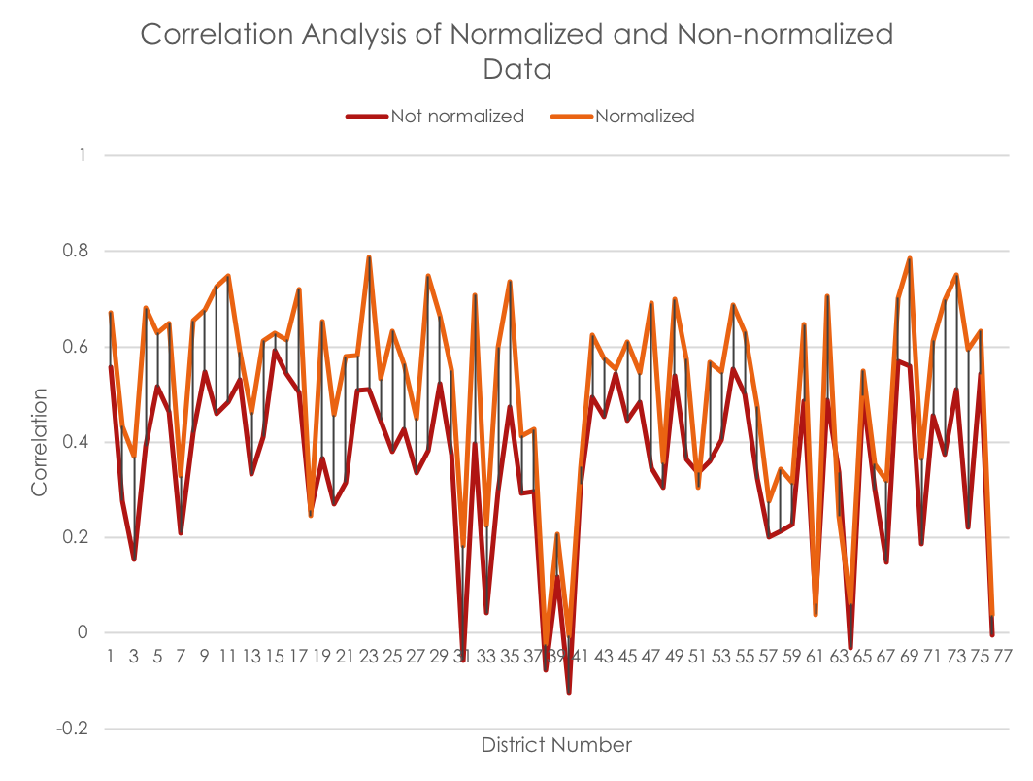

Figure 5.2 Correlation comparison with and without Normalization

### 5.2.2 Outlier Removal with Convex Hull Iterative Approach

We propose to use an iterative outlier removal method. The experimental analysis revealed that each level of outlier removal process increased the correlation between rainfall and dengue incidence. The concept behind the approach is to eliminate outliers and hence increase the correlation. The following set of figures show three levels of outlier removal process and their corresponding correlation values. Figure 5.3 shows set of provinces undergone outlier removal and Figure 5.4 shows correlation values for each province in each level of removals.

|  |  |
| --- | --- |
| Amnat Charoen | Ang Thong |
| Bangkok | Bueng Kan |

Figure 5.3 Multi Level Outlier Removal with Convex Hulls (v1-rainfall, v2-dengue incidence)

Figure 5.4 Correlation for all Provinces at each Outlier Removal Level

It is clear from the Figure 5.4 that correlation between rainfall and dengue incidence is increased with the outlier removal. For a couple of provinces, the correlation is not improving as expected. There can be other influencing factors or reporting errors for those provinces such as efficiency of waste management, patients from outside district admitted to these provinces etc. For most of the provinces there is a good or considerable improvement which is helping SVR to perform better.

The remainder of the results are organized as follows. Spatial non-stationarity behavior of the dengue epidemic is studied in Sri Lanka and results are presented. The generation of prediction models was applied to data from Thailand and results are presented. As per the fact that there is no real data available for resources, a thorough testing was conducted on synthetic data for resource allocations with the proposed Genetic Algorithm approach.

We conducted a thorough analysis in Sri Lanka which gave a clear understanding on how the dengue epidemic is geographically varying. The study conducted in Sri Lanka revealed the usage of province specific prediction models will outperform global prediction models. The results are listed in the following section.

## 5.3 Results of GWR and Least Square Analysis of Dengue Epidemics in Sri Lanka

### 5.3.1 Least Square Analysis

In ordinary least square results Variance Inflation Factor (VIF) values shows whether the predictor variables are multicollinear. A higher VIF value indicates there is a correlation between predictor variables. The VIF for the analysis was less than 10. The lower VIF value (< 10) indicates that the variables are not multicollinear. In this study, rainfall and population density was used as explanatory variables. The VIF value indicates that every explanatory variable that were used (rainfall and population) is unique and contributing to the variation in dengue incidence. Ordinary least square regression result also shows that the Adjusted R-Squared value is 0.332054 for the year 2014. This indicates the model built with a combination of population density and rainfall data explains 33.2% of the variation in dengue incidences. According to the OLS regression results, all explanatory variables (rainfall and population density) are statistically significant but the value for Jarque-Bera statistics is also significant. Significance in Jarque-Bera statistics indicates that the model is biased and hence undesirable. Also, the Koenker test is statistically significant (P value < 0.01 for both rainfall and population). This implies non-stationary relationship between the dependent and some or all of the explanatory variables. That reveals that the explanatory variables (rainfall and population density) behave differently in different spatial regions. The above results were obtained using Arch GIS software.



Figure 5.5 The spatial distribution of dengue incidence from 2011 to 2015 in Sri Lanka.

### 5.3.2 Geographically Weighted Regression (GWR) analysis

For GWR, adaptive kernel was used as kernel type and Akaike Information Criterion (AIC) was selected as bandwidth. AIC automatically selects the number of neighbors for smooth analysis. AIC can be used to compare two different models generated with regression analyses. AIC value for OLS is greater than that in GWR. Hence GWR is a better analysis tool for dengue incidence with rainfall and population density as explanatory variables.

The GWR model results show that the Adjusted R-Squared values is 0.5632 (R2). This indicates the model generated with population density and rainfall as explanatory variables can explain 56.3% of the variance in dengue incidences in 2014. These results also reveal that there are other variables besides population density and rainfall data that have stronger relationships with dengue incidence. These variables are not included in the model. GWR can only determine that the variables used in the analysis can explain the dengue incidence fully. Whereas the cannot be used to find the other variables that may contribute to the variation in the dengue incidence. They have to be identified by experimenting with various candidate explanatory variables.



Figure 5.6 The GWR standard residual map for dengue incidence with rainfall and population density for the year 2014.

The standard residual map for the model developed for dengue incidence is shown in the Figure 5.6. The red areas indicate under estimated regions where the actual number of dengue cases is higher than the model predicted values. The blue areas indicate over estimated regions where actual dengue cases are lower than predicted values. Random distribution of red or blue areas indicate the model performs well. Whereas, cluster of red or blue areas indicate under/over estimation of the model giving poor performance. Spatial clustering of over/under prediction indicates missing one or more key explanatory variables in the model. The standard residual map in Figure 5.6 shows clustered over and under predicted areas.

In order to establish confidence in our model, it is required to find how well each explanatory variable predicts the dengue incidence for each administrative region. It is revealed from previous sections that there are no global explanatory variables that hold consistent relationship across administrative regions. An analysis was conducted to reveal the variation in strength of explanatory variables in each administrative region in explaining the relationship between the variable and dengue incidence. Results of the analysis are shown in

Figure 5.7 (a) and (b).

Figure 5.7 (a) provides the spatial distribution of regression coefficients for rainfall and

Figure 5.7 (b) provides the same for population density. Lighter colors represent lower coefficients and darker colors represent higher coefficients.

Mapping these coefficients shows the relationship between each explanatory variable and the dependent variable that how they change across the study area. The darker areas in figures indicate the explanatory variables, rainfall and population density, are strong predictors of the dengue incidence, whereas, the lighter areas are locations where they are comparatively weak.

GWR regression results show that relationship of incidence with rainfall and population density is spatially varying across districts of Sri Lanka.

Figure 5.7 (a) shows that spatial distribution of regression coefficient of population density is a strong predictor in eastern coastal areas in Trincomalee district, and a weak predictor in Mannar.

Figure 5.7 (b) also shows that spatial distribution of regression coefficient of rainfall is a strong predictor in northern areas including Mannar and in eastern coast it is a weak predictor. There is an inverse effect of rainfall and population density on dengue incidence. When rain becomes a strong predictor in some areas, population density is a weak predictor and vice versa. It is very important to understand this variation for making local policies to mitigate dengue. GWR model can also be used to predict values of dependent variables for locations within the study area with unseen explanatory variables values. This will give an estimate of the dependent variable (dengue incidence) using the regression model generated.



Figure 5.7 The spatial distribution of regression coefficients for (a) population density (b) rainfall.

## 5.4 Generating Prediction Models for Dengue Epidemic in Thailand

The prediction models for Thailand is generated and evaluated. The results are given in the following sections.

5.4.1 Dengue Incidence in Thailand

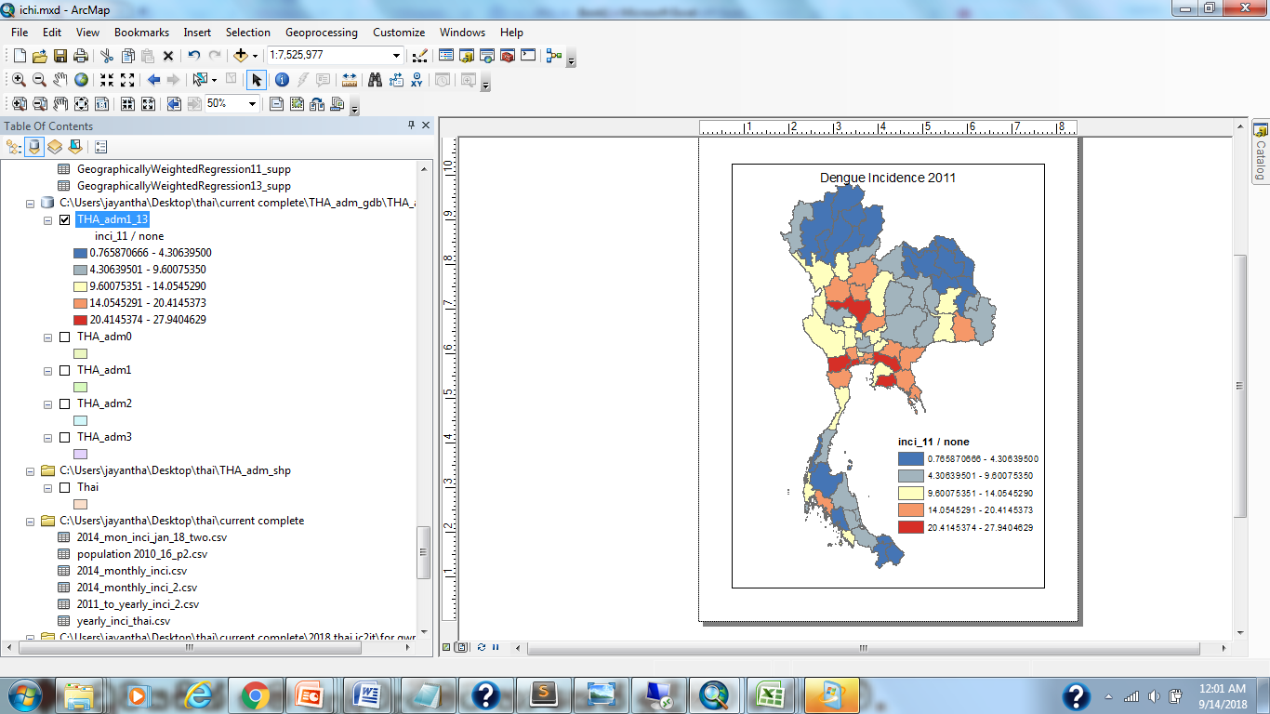

Figure 5.8a Dengue Incidence Map of Thailand in 2011

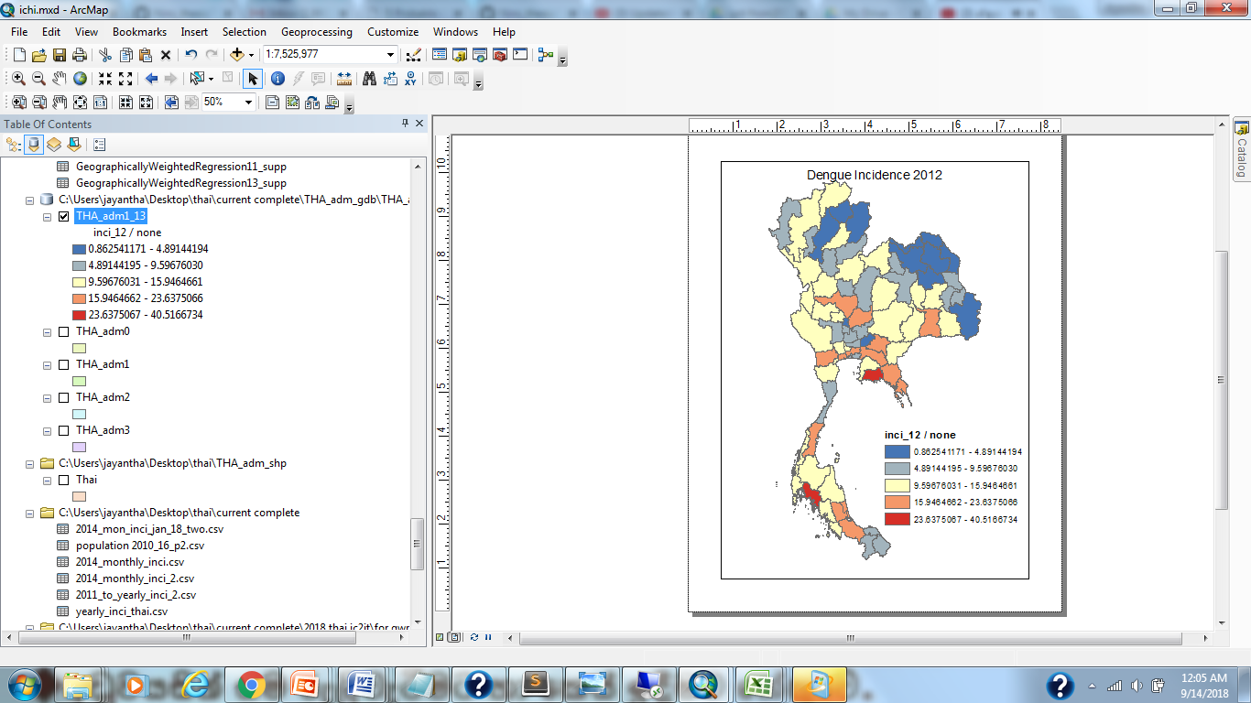

Figure 5.9b Dengue Incidence Map of Thailand in 2012

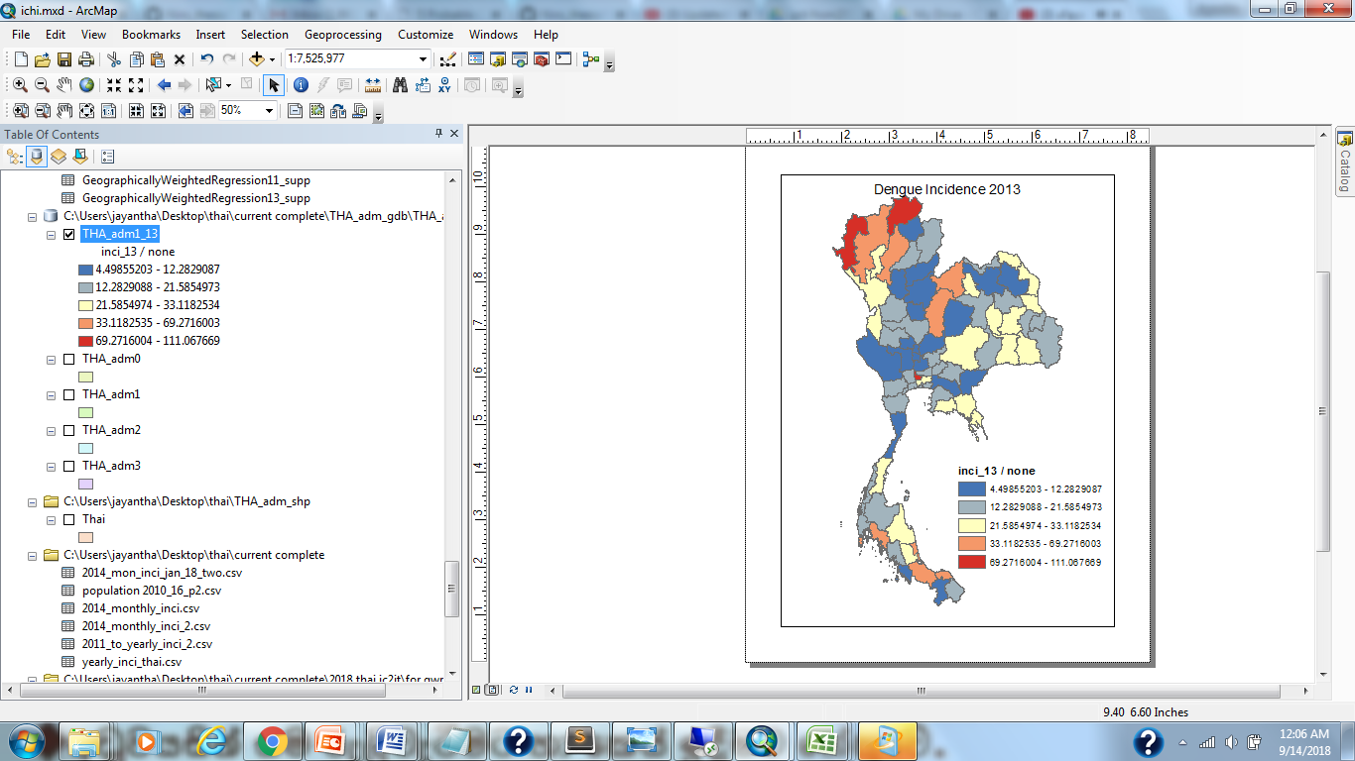

Figure 5.10c Dengue Incidence Map of Thailand in 2013

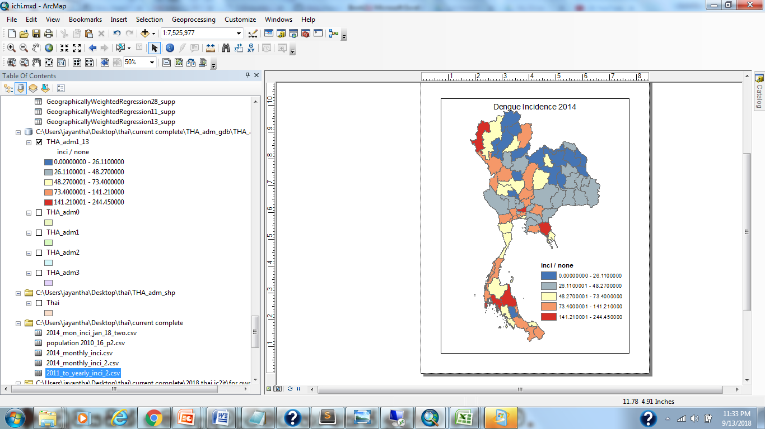

Figure 5.11d Dengue Incidence Map of Thailand in 2014

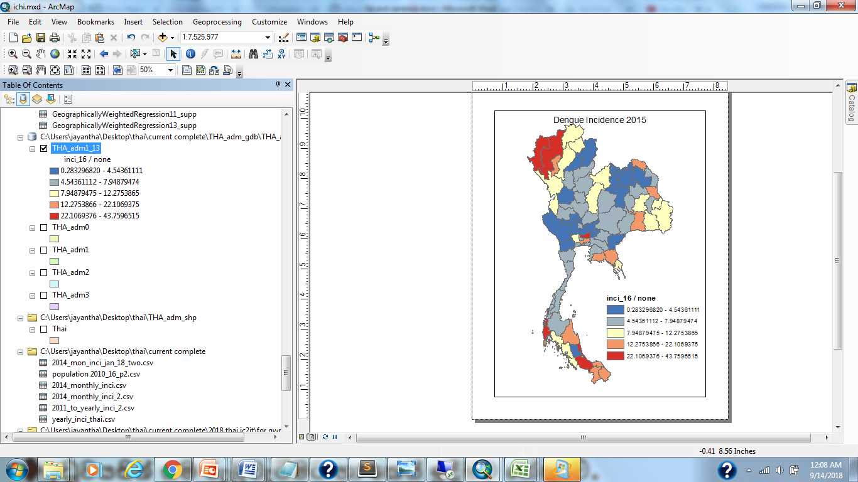

Figure 5.12e Dengue Incidence Map of Thailand in 2015

Multiple phases of testing were conducted on the same data set with multiple levels of noise removals. A separate SVR model was trained for each district. Each model was validated using 10-fold cross validation. SVR models are assessed using MSE and proposed accuracy calculation method. Finally, multiple classifiers are combined and generated a micro ensemble to eliminate bias in each classifier for a given district.

### 5.4.2 Prediction Results for a Global Model

The global model contains data from all 76 provinces. Each data point is treated the same way as all the other and geographical variations re not considered. There is a single SVR is trained on the entire data set. The plot of rainfall vs. dengue incidence is depicted in

Figure 5.13. The results for various scenarios are listed below.

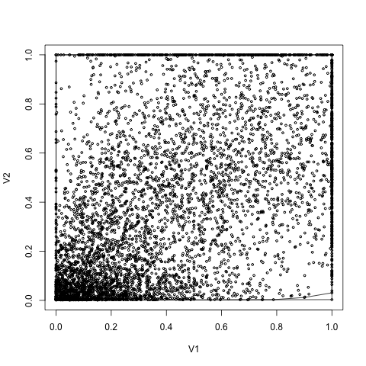

Figure 5.13 Plot of Rainfall vs Dengue Incidence for the Global Dataset (v1-rainfall, v2-dengue incidence)

Correlation of dengue incidence to rainfall for global dataset is 0.523. As per the

Figure 5.13, it is clear that the global model has many outliers that result in a lower correlation coefficient. It is hard to determine an optimal value for the level of outlier removals. Correlation coefficient for 3 levels of outlier removal is given in the Table 5.1. SVR model validation results from 10-fold cross validation with no outlier removal are given in the Table 5.2.

Table 5.1 Correlation Coefficient for Three Levels of Outlier Removals on Global Dataset

|  |  |
| --- | --- |
| Level of outlier removal | Correlation Coefficient |
| Level 0 | 0.523 |
| Level 1 | 0.524 |
| Level 2 | 0.525 |

As per the table, it is clear that the increase in correlation coefficient in each level of outlier removal is very small. It is advisable to have many levels of outlier removals to get a higher coefficient for correlation. There is no means by which the optimum number of outlier removals is estimated. The result obtained from the global model using 10-fold cross validation is listed in Table 5.2. Note that the accuracy is calculated based on the method proposed in this study.

Table 5.2 Results of 10-fold Cross Validation of SVR on Global Dataset

|  |  |  |
| --- | --- | --- |
| Fold | Accuracy | MSE |
| 1 | 63.25 | 0.19322216 |
| 2 | 56.85 | 0.20835374 |
| 3 | 59.23 | 0.20811646 |
| 4 | 55.94 | 0.21453015 |
| 5 | 63.07 | 0.19367864 |
| 6 | 59.41 | 0.20107433 |
| 7 | 58.68 | 0.20458908 |
| 8 | 60.51 | 0.2005876 |
| 9 | 60.14 | 0.20600364 |
| 10 | 59.04 | 0.20545753 |
| Average | 59.61 | 0.20356133 |

### 5.4.3 Prediction Results for Local Models

Each district is considered as a separate entity and having unique characteristics. Hence, the models generated for individual province is specific to that particular province. The results of local models trained for 76 provinces are given below.

Three models generated for the same data set and validated based on 10-fold cross validation. These three models are SVR, LS, and k-NN. The best performing models are then used in ensemble generation and achieve better output from the ensemble model. The best performing models are determined by the accuracy of the model for the training data set. The models that generate the average accuracy of 75 or above is selected into the ensemble. The ensemble model then be used in prediction and risk estimation. The models are generated based on SVR, Least Square and K-NN tools. Performance of each model in each outlier removal level along with the performance of ensemble is given in Figure 5.14, Figure 5.15 and Figure 5.16 for level of outlier removals 0, 1 and 2 respectively. It is apparent from the figures that the accuracy improvement with each level of outlier removal.

Figure 5.14 The model performance without outlier removal

Figure 5.15 The model performance with level1 outlier removal

Figure 5.16 The model performance with level2 outlier removal

## 5.5 Resource Allocation

We performed resource allocation on four different synthetic datasets confirming to the setting listed in the Table 5.3. We listed the complete setup for the Trial 1 and list only best fit value graph and the allocation results for the remaining trials. All the other results are found under appendix A. The experiment was carried out on a synthetic data set. This is due to the fact that the real data is not available for many different experiment setups. And also, there are no estimated population data for future dates available at present. The required information for facilities is not available such as number of hospital beds required, number of healthcare professional needed, etc. The other important reason for us to use the synthetic data is to stress test the proposed algorithm. We can emulate different scenarios that will put the proposed algorithm at extreme ends and test for performance.

Table 5.3 Experimental Trial Setup

|  |  |  |  |
| --- | --- | --- | --- |
| Trial No | Number of facilities | Number of Resources | Facility Properties |
| 1 | 10 | 10 | 3 |
| 2 | 50 | 5 | 3 |
| 3 | 100 | 10 | 3 |
| 4 | 500 | 10 | 3 |

Performance Comparison of GA with random and sliding mutation with lock chromosome

### 5.5.1 Trial 1

Table 5.4 Facility Information (High risk facility is highlighted)

|  |  |  |
| --- | --- | --- |
| **Population** | **Risk** | **Area** |
| 293,931 | 4,435 | 259 |
| 424,873 | 2,722 | 619 |
| 300,904 | 1,930 | 743 |
| 222,133 | 4,372 | 195 |
| 185,651 | 2,426 | 328 |
| 257,318 | 2,368 | 354 |
| 453,762 | 2,720 | 522 |
| 141,650 | 1,956 | 493 |
| 402,820 | 1,555 | 128 |
| 259,771 | 1,944 | 840 |

Table 5.5 Resource Availability

|  |  |  |  |  |  |  |  |  |  |
| --- | --- | --- | --- | --- | --- | --- | --- | --- | --- |
| **R1** | **R2** | **R3** | **R4** | **R5** | **R6** | **R7** | **R8** | **R9** | **R10** |
| 1,304 | 7,441 | 7,297 | 980 | 6,276 | 9,691 | 5,735 | 6,476 | 2,754 | 146 |

Table 5.6 Requested Resources from each facility

|  |  |  |  |  |  |  |  |  |  |  |
| --- | --- | --- | --- | --- | --- | --- | --- | --- | --- | --- |
| **Resource**  **Facility** | **R1** | **R2** | **R3** | **R4** | **R5** | **R6** | **R7** | **R8** | **R9** | **R10** |
| F1 | 43 | 369 | 362 | 49 | 208 | 481 | 190 | 214 | 91 | 5 |
| F2 | 66 | 564 | 553 | 74 | 317 | 734 | 290 | 327 | 139 | 7 |
| F3 | 55 | 467 | 458 | 61 | 262 | 608 | 240 | 271 | 115 | 6 |
| F4 | 207 | 1,770 | 1,735 | 233 | 995 | 2,305 | 909 | 1027 | 437 | 23 |
| F5 | 102 | 875 | 858 | 115 | 492 | 1,140 | 450 | 508 | 216 | 11 |
| F6 | 207 | 1,770 | 1,735 | 233 | 995 | 2,305 | 909 | 1,027 | 437 | 23 |
| F7 | 129 | 1,108 | 1,087 | 146 | 623 | 1,444 | 570 | 643 | 273 | 14 |
| F8 | 164 | 1,400 | 1,373 | 184 | 787 | 1,823 | 719 | 812 | 345 | 18 |
| F9 | 189 | 1,614 | 1,583 | 213 | 908 | 2,102 | 829 | 936 | 398 | 21 |
| F10 | 143 | 1,225 | 1,201 | 161 | 689 | 1,595 | 629 | 711 | 302 | 16 |

Table 5.7 Lock Chromosome

|  |  |  |  |  |  |  |  |  |  |
| --- | --- | --- | --- | --- | --- | --- | --- | --- | --- |
| 0 | 0 | 0 | 0 | 1 | 0 | 1 | 1 | 1 | 1 |

Performance of the proposed algorithm is compared against the standard GA. Two variations of the proposed algorithm are also presented, with sliding mutation and without sliding mutation. In both variations, the constraints have been used when generating the population and in both mutation operations and cross over operations. There are three scenarios presented in each performance measurement figures. Those are random-best, sliding-best and no-sliding-best. The random-best scenario is the performance of the standard GA. The other two are the performance of the proposed GA. The sliding-best uses the proposed sliding mutation along with constrained population generation and constrained mutation and cross overs. Whereas no-sliding-best uses only constrained operations.

Performance of the GA for random, no-sliding with constraints and sliding with constraints Gas are described in the following section.

There are 10 facilities with four properties. Each facility is requesting 10 different resources. The performance of each category is shown in Figure 5.17.

Figure 5.17 The performance of proposed GA for 10 facilities requesting 10 resources

The performance of the three scenarios are different and the proposed GA has a better performance compared to the standard GA. The starting fitness value of the best fit chromosome for the random allocation is low. The random generation of population with random allocation of resources creates a population with a higher variance in the fitness values. Some of the chromosomes may not be even viable in the problem context. The allocated resources may exceed the available resources and hence the chromosome is not applicable in the dengue mitigation. The proposed algorithm with constraints only and constraints with sliding mutation start with almost the same best fit value. The performance of the sliding mutation out run the constraints only scenario after a few iterations. The sliding mutation scenario is reaching the final best fit value faster than the no-sliding scenario. The main reason for the faster convergence is the guided mutation and cross overs in the algorithm. That helps the algorithm to move the chromosomes towards the final best fit value faster.

Resource Allocation Results of Trial 1 for high risk facility and low risk facility are shown in Figure 5.18 and Figure 5.19.

Figure 5.18 High risk facility

Figure 5.19 Lowest risk facility

### 5.5.2 Trial 2

The performance of the GA for random, no-sliding with constraints and sliding with constraints Gas for 50 facilities with four properties was tested. Each facility is requesting 5 resources. The performance of the trial 2 is shown in Figure 5.20.

Figure 5.20 Performance of the proposed GA for 50 facilities and 5 resources

The high-risk facility is the facility with id 27. The following graphs (Figure 5.21) show the resource allocation for the facility 27 with random GA and sliding with constrained GA.

Figure 5.21 The resource allocation for the high-risk facility of Trail 2

### 5.5.3 Trial 3

The performance of the GA for random, no-sliding with constraints and sliding with constraints GA for 100 facilities with 4 properties that request for 10 resources was tested. Performance is shown in Figure 5.22

Figure 5.22 The performance of the proposed GA for 100 facilities with 10 resources

The high-risk facility is the facility with id 49. The following graphs (Figure 5.23) shows the resource allocation for the facility 49 with random GA and sliding with constrained GA.

Figure 5.23 The resource allocation for the Trail 3

### 5.5.4 Trial 4

The performance of the GA for random, no-sliding with constraints and sliding with constraints GA for 500 facilities with 4 properties that request for 10 resources was tested. Performance is shown in Figure 5.24.

Figure 5.24 The performance of the proposed GA for 500 facilities with 10 resources

The high-risk facility is the facility with id 377. The following graphs (Figure 5.25) show the resource allocation for the facility 377with random GA and sliding with constrained GA.

Figure 5.25 The resource allocation for the Trail 4

## 5.6 Comparison of Proposed GA with Sliding Mutation against Standard GA with Random Allocation and Mutation

The standard GA with random population generation and mutation is always starting with a lower fitness value. The variation in fitness value among each individual is very high giving a very lower value of average fitness value compared to best fit value. In contrast, the proposed GA is always starting with a higher fitness value for both best fit values and average fitness value. The difference between best fitness and average fitness is small for the proposed GA as the constrained based population generation always produces offspring that are closer to the target chromosome. Every individual in the population reaches the best fit value faster in the proposed algorithm. The rate of change of the best fitness value and the average fitness value coincide after several iterations. Whereas, the average and the best fitness value does not coincide until many iterations in the standard GA. These observations are clearly shown in Figure 5.26. The proposed GA out performs the standard GA in all four trials. The fitness value of the best fit chromosome of the proposed algorithm is always start with a higher value than the standard GA in all four trials. The rate of reaching the final best fitness value of the proposed algorithm is always higher than that of the standard GA. The four trials are setup to cover several scenarios with different amount of resources and facilities. The space complexity was linearly increased for both algorithms when the number of facilities were increased. The time complexity follows the same trend and was increased along with the number of facilities.

The resource allocation performance was higher for the proposed algorithm as compared to the standard GA. The standard GA treats all the facilities with the same priority. This will result in allocating resources randomly assigning the high-risk facilities the same priority. The high-risk facilities must be treated with a high priority so that the requested resources are allocated fully for the facility. The low risk facilities do not need a priority treatment. The amount of resources available is generally less than the total amount of requested resources in developing countries due to resource scarcity. A priority treatment is mandatory for high risk facilities. The proposed algorithm is capable of assigning different priorities based on the risk of the facility. This scheme will help to efficiently and effectively allocate resources to the facility where it is mostly needed.

The risk-based resource allocation performs well in all four trials. For instance, the trial 1, allocated requested resources for the high-risk facility very closely. Whereas the low risk facility was allocated fewer amount of resources than requested. The standard GA allocates resources for the lower risk facility better than the proposed algorithm. The standard GA is not performing well if we consider total resource allocation and the total system risk. The standard GA did not properly allocate resources for the high-risk facility. The proposed algorithm, on the other hand, balances out the resource allocation and reduce the total risk of the resource allocation across all the facilities.

Sliding-best

Sliding-average

Figure 5.26 Comparison of standard GA and the proposed GA

# SUMMARY AND FUTURE DIRECTIONS

The burden of dengue has been increasing globally during the past couple of decades. The WHO reported that the dengue epidemic is now spreading towards the western countries. Asian countries have already been experiencing major epidemics since last couple of decades. Thailand has been reported its largest dengue epidemic in 2018. Sri Lanka is suffering from dengue epidemics since 1960s and dengue has become a major public health issue at present with a high morbidity and mortality. In 2009, dengue infections increased at an alarming rate across Sri Lanka. There were 35,095 dengue infections reported in 2009. During the first 10 months of the year 2017, 15,8854 suspected dengue cases have been reported to the Epidemiology Unit of Sri Lanka keeping the mortality rate at an alarming level which was about 300 deaths. The Epidemiology Unit of Sri Lanka is making a constant effort to mitigate the dengue epidemics. The ever-increasing dengue incidence reported proved that the strategies that were used, are not sufficient to completely control the epidemic. There is an urgent need for a comprehensive mitigation plan to manage the impact of the epidemic. This study proposed a computational approach for efficient dengue epidemic prediction and mitigation. The proposed study addresses several major aspects of the mitigation process, which are data validation and analysis, dengue epidemic prediction and resource allocation for an efficient mitigation plan.

A set of regressors arranged in an ensemble was used in dengue incidence prediction. Each regressor is trained on three major influencing factors, that are rainfall, temperature and population density. The climate factors were extracted from remote sensing data available through two data portals, NASA NEO data portal was used to obtain temperature data and JAXA data portal was used to obtain rainfall data. The two web data portals provide climate data for the entire globe. A preprocessing step is needed to extract relevant data for the two countries, Sri Lanka and Thailand.

The data sets that were used in the proposed study contained noise, instrumental reporting errors (satellites), or human reporting errors. We follow several steps to remove these data points from the datasets that were used in the model generation. In addition to the noise data, year specific events introduced biased in the dengue incidence reported. For instance, years with specific environmental event such as flooding, droughts introduced alien effects in the reported dengue incidence over rainfall and temperature effects. The proposed framework consists a yearly data normalization step to eliminate year specific effects from the data set. The technique of yearly data normalization increased the correlation between the rainfall and the dengue incidence compared to that without yearly normalization. The increase in correlation is above 0.3 for some provinces. The increase in coefficient is visible in 73 provinces out of 76 provinces. There is an at least 0.1 increase in correlation for more than 70% of the privinces after the year-wise normalization was applied. There is no increase in the coefficient for the province Saraburi. The rationale behind the Saraburi to have lower coefficient and not responding to yearly data normalization is unknown and need further investigations. We keep further analysis of these scenarios as a future work of this study.

We proposed to use a novel outlier removal method to detect and remove noise (outliers) in the data sets. The proposed method uses an iterative method and utilize convex hulls for the detection and removal of outliers. Multiple level of outlier removal is available with the method proposed. The prediction results of the data sets were increased after the noise removal applied to the original data set. This technique increased the correlation of the rainfall and the dengue incidence for 73 out of 76 provinces. Pathum Thani, Phangnga, and Saraburi provinces have very low correlation coefficients and the reason for low correlations is unknown. The correlation coefficients are not increasing even for the 3rd level of outlier removal for those provinces. There is an at least 0.1 increase in the coefficient for more than 50% of the provinces after the 3rd level of noise removal was applied. In some province, the increase in correlation coefficient is more than 0.2 and it was a significant improvement in the model generation. The average amount of increase in the accuracy after the preprocessing steps was about 20%.

The behavior of the dengue epidemic is geographically dependent. The majority of the studies conducted before this study were using a global model to explain the dengue behavior of the whole country. We conducted a preliminary study to evaluate the current practices. The preliminary study conducted in Sri Lanka revealed the geographical dependency of the dengue. The finding of the preliminary results proved that there must be a model generated locally. Therefore, we generated a separate model for each geographically distinct area. Initial experimentation with the local model revealed that there is no global model that performs well in all the regions. Different types of regressors are necessary to model the behavior in each region. We proposed to use a regressor ensemble for each distinct region. The proposed ensemble is generated with the best performing regressors for each region. The fluctuation of the performance can be moderated with the use of regressor ensemble instead of a single model. The proposed regressor ensemble was used to predict the dengue epidemic and identified the high-risk areas. We used Support Vector Regression (SVR), Least Square Regression (LS), and KNN regression to generate the ensemble. The SVR and LS performed competitively for different districts. The ensemble was mostly made from SVR and LS. KNN was the weak regressor for all the districts.

The regular regression validation is done through mean square error (MSE) and adjusted R2. The MSE and adjusted R2 are affected by the outliers. The MSE and R2 are bias when extreme outliers are present in the dataset. A novel method of accuracy calculation of regressions was also introduced to overcome the shortcoming of the MSE and adjusted R2. methods. The proposed method uses a concept of confidence boundary where the predicted values falling inside the confidence boundary treated as correct predictions. Whereas predicted vales falling outside of the confidence boundary are treated as incorrect predictions. The proposed method can be used to evaluate the standard regressions with accuracy instead of MSE.

The rainfall, temperature, and population densities were used in the model training. The results would improve if the model were trained with more influencing factors. The past studies identified several other factors such as waste management, water bodies in the region, etc. We propose to further study these areas and identify several other major actors that might improve the performance of the ensembles. And also, it is desirable to rank influencing factors and eliminate weak influencing factors from the model training. A separate study is needed to analyze the rankings of the influencing factors and determine important influencing factors in the model generation.

The generated ensembles can be used to identify the risk areas of the upcoming dengue epidemic. Each ensemble made for each district was trained on the past climate and population data. The prediction is done on the forecasted climate and estimated population data. The forecasted climate and population data are fed in to the trained ensemble and obtained the output. This output closely estimate the dengue incidence that may occur in each district if a dengue epidemic would occur. The predicted value is used in the risk calculation for the district. The risk was calculated as the normalized value of the risks in each district. The estimated risk values are used in the resource allocation stage explained in the next section.

The resources for mitigation of the dengue epidemic are scarce in developing countries such as Sri Lanka. An effective resource allocation technique is a major component in a dengue mitigation framework for the generation of an effective response plan. We proposed to integrate a priority-based resource allocation based on the risk associated with each district. The risk values are obtained from the ensemble for the upcoming epidemic. This risk value is associated into the facilities located in the corresponding district.

The proposed resource allocation methodology was modeled based on the state-of-the-art Genetic Algorithm (GA) with major modifications to the algorithm. The mutation, cross-over and initial population generations are modified to introduce constraints and to match the problem domain. In addition, the proposed GA introduced sliding mutation scheme in which the amount of mutation applied to a gene is determined based on the risk and the current allocation for the facility (gene). The proposed mutation operation considers the resource availability and constrained to the amount of available resources. This method is contrast to the standard random mutation found in the standard GA. The proposed cross-over operation is applied on the chromosome with the facility boundary preserved. The cross-over cannot split a chromosome at a random point. The cross-over point must be a facility boundary in the chromosome. The sliding mutation introduced ensure fast convergence as the amount of mutation is proportional to the distance of the chromosome to the target chromosome. When the distance is large, the amount of mutation is large and vise versa. This will enable proposed GA to quickly converge to the best fit chromosome. The time and the space complexity of the standard GA remains the same with the proposed GA. The results obtained from the proposed GA outperformed the standard GA in all the trials ran over 10,000 iterations. The proposed data cleaning, problem modeling, and resource allocation methods are promising and proved by the generated results.

## 6.1 Future Directions

The proposed study successfully reached the goals set forth in the beginning of the study. Despite, there is still some areas that can be improved. And also, one can propose new method to improve some areas of the proposed study. One of the areas that can be improved is the data pre-processing. There are several provinces in Thailand that do not respond to the outlier removal method proposed in this study. There must be some other factors, that were not studied in this work, affecting the relationship between dengue incidence and the climate factors. A research study can focus on the data pre-processing and improve the relationship between dengue incidence and influencing factors where there is a no strong correlation.

The proposed study used provinces’ average for climate data. This can be extended to use areas smaller than districts. The climate data is available at 0.1-degree level giving about 10km wide areas. The challenge to be addressed when using smaller areas is the availability of dengue incidence for the smaller areas. A technique to estimate dengue incidence for smaller areas must be developed. This approach would be able to closely capture the effect of climate factors on the spread of dengue epidemic. We propose to use thousands of micro ensembles in place of hundreds proposed in the current study.

The other area to be improved is the speed of the proposed GA applied on a larger number of facilities. The proposed GA can process up to 500 facilities for 10 resources within one-hour period on a desktop computer with 2.5 GHz Quadcore CPU and 3 GB of RAM. It is highly recommended to improve the proposed GA through another study to speed up the allocation process. We propose to use massive parallelism to achieve high speed computations in the GA. An algorithm that exploit massive parallelism is desired.

The proposed research study created the foundation for an automated dengue mitigation system to be built on. I propose a web-based system to manage every aspect of the dengue mitigation from data cleaning to resource allocation. The proposed algorithms will be hosted in a web server and respond to various user queries. In addition, the web-based system will facilitate to enter the dengue incidence data for a given province. Then the system will automatically integrate the new data into the existing algorithm and updates the models to accommodate new information This will ensure that the response planes generated based on the recommendations provided by the web-system are up to date. The web-based system will also be capable of generating risk maps for a given climate and population parameters (prediction). And also, the system will facilitate to run the resource allocation based on the predicted risk map. The resources and the demand of each facility can be entered into the web system through the user interfaces provided.

The mobile devices are getting popular in recent years. The users favor mobile apps over desktop apps as it is portable and accessible at any time. I propose to develop a mobile app (iOS and Android to make it widely available) to acquire recent data from the general public. This will eliminate the need for waiting for government officials to update their data portals. There will be a mechanism to verify the user reported data at the web server. Once verified, the user entered data will be added to the models and start generating risk maps based on the latest data.

# BIBLIOGRAPHY

1. Sirisena PDNN., Noordeen F. “Evolution of dengue in Sri Lanka—changes in the virus, vector, and climate”. International Journal of Infectious Diseases, 19 (2014) 6–12
2. Neill II MO, Mikler AR, and Schneider T. An Extensible Software Architecture to Facilitate Disaster Response Planning. 2011.
3. Vitarana T, Jayakuru WS. Historical account of dengue haemorrhagic fever in Sri Lanka. WHO/SEARO Dengue Bulletin 1997; 21:117–8.
4. Kanakaratne N, Wahala MP, Messer WB, Tissera HA, Shahani A, Abeysinghe N, et al. Severe dengue epidemics in Sri Lanka 2003–2006. Emerg Infect Dis 2009; 15:192–9
5. Kusumawathie PH, Fernando WP. Breeding habitats of Aedes aegypti Linnaeus and Ae. albopictus Skuse in a dengue transmission area in Kandy, Sri Lanka. The Ceylon Journal of Medical Science 2003; 46:51–60
6. Kusumawathiea PH, Yapabandarab AM, Jayasooriyaa GA, Walisingheca C. Effectiveness of net covers on water storage tanks for the control of dengue vectors in Sri Lanka. J Vector Borne Dis 2009; 46:160–3
7. McMichael AJ, Woodruff RE, Hales S. Climate change and human health: present and future risks. Lancet 2006; 367:859–69
8. Dorji T, Yoon IK, Holmes EC, Wangchuk S, Tobgay T, Nisalak A, et al. Diversity and origin of dengue virus serotypes 1, 2, and 3, Bhutan. Emerg Infect Dis 2009; 15:1630–2.
9. Department of Health Service, Sri Lanka. Annual health bulletin of Sri Lanka. Colombo, Sri Lanka: Department of Health Services; 2002.
10. Briet OJ, Galappaththy GN, Konradsen F, Amerasinghe PH, Amerasinghe FP. Maps of the Sri Lanka malaria situation preceding the tsunami and key aspects to be considered in the emergency phase and beyond. Malaria J 2005; 4:8.
11. Ministry of Health, Sri Lanka. Surveillance report on dengue fever/dengue haemorrhagic fever 2007. Epidemiological Bulletin 2008; 49:1–20.
12. Ministry of Healthcare and Nutrition of Sri Lanka. Monthly distribution of suspected dengue cases from 2004 to 2010 by District in Sri Lanka. Ministry of Healthcare and Nutrition of Sri Lanka, 2011. Available at: http://www.epid.- gov.lk/Den- gue_updates.htm (Accessed on 20th of August 2013).
13. Martha A, Yuzo A. Male–female differences in the number of reported incident dengue fever cases in six Asian countries. Western Pac Surveill Response J 2011;2
14. Weaver SC, Reisen WK. Present and future arboviral threats. Antiviral Res 2010; 85:328.
15. Cavrini F, Gaiban P, Pierro AM, Rossini G, Landini MP, et al. Chikungunya, an emerging and spreading arthropod-borne viral disease. J Infect Dis 2009; 3:744– 52.
16. Rezza G, Nicoletti L, Angelini R, Romi R, Finarelli AC, et al. Infection with chikungunya virus in Italy: an outbreak in a temperate region. Lancet 2007; 370:1840–6.
17. Scott TW, Morrison AC. Vector dynamics and transmission of dengue virus: implications for dengue surveillance and prevention strategies: vector dynamics and dengue prevention. Curr Top Microbiol Immunol 2010; 338:115.
18. Shope RE. Global climate change and infectious diseases. Environ Health Perspect 1991; 96:171–4.
19. Ward MA, Burgess NR. Aedes albopictus: a new disease vector for Europe. J R Army Med Corps 1993; 139:109–11.
20. Kalra NL, Kaul SM, Rastogi RM. Prevalence of Aedes aegypti and Aedes albopictus vectors of DF/DHF in North, North East and Central India. Dengue Bulletin 1997; 21:84–92.
21. Chun L, Telisinghe PU, Hossain MM, Ramasamy R. Vaccine development against dengue and shigellosis and implications for control of the two diseases in Brunei Darussalam. Brunei Darussalam Journal of Health 2007; 2:60–71.
22. Ooi EE, Goh KT, Gubler DJ. Dengue prevention and 35 years of vector control in Singapore. Emerg Infect Dis 2006; 12:887–93
23. C.W. Lian, C.M. Seng and W.Y. Chai, “Spatial, Environmental and Entomological Risk Factors Analysis on a Rural Dengue Outbreak in Lundu District in Sarawak, Malaysia”, Tropical Biomedicine, vol. 23(1), pp. 85-96, 2006.
24. S. B. Seng, A. K. Chong and, A. Moore. “Geostatistical Modelling, Analysis and Mapping of Epidemiology of Dengue Fever in Johor State, Malaysia”, The 17th Annual Colloquium of the Spatial Information Research Centre University of Otago, Dunedin, New Zealand, 2005.
25. N. Rachata, P. Charoenkwan, T. Yooyativong, K., Chamnongthai C. Lursinsap and K. Higuchi, “Automatic Prediction System of Dengue Haemorrhagic-Fever Outbreak Risk by Using Entropy and Artificial Neural Network”. International Symposium on Communications and Information Technologies (ISCIT 2008), pp. 210-214, 2008.
26. T. Van Gestel, J.A.K. Suykens, D.E. Baestaens, A. Lambrechts, G. Lanckriet, B. Vandaele, B. De Moor, and J. Vandewalle, Financial time series prediction using least squares support vector machines within the evidence framework, IEEE Trans. On Neural Networks, vol. 12. Issue 4, pp. 809-821, (2001).
27. D. Mckay and C. Fyfe, Probability prediction using support vector machines, In Proceedings of Int. Conference on Knowledge-Based Intelligent Engineering Systems and Allied Technologies, vol. 1, pp. 189-192, (2000).
28. A. Fan and M. Palaniswami, Selecting bankruptcy predictors using a support vector machine approach, vol. 6, pp. 354-359, (2000).
29. F. Tay and L.J. Cao, Modified support vector machines in financial time series forecasting, Neurocomputing, Sept., (2001).
30. Soemsap, T.; Wongthanavasu, S.; Satimai, W., "Forecasting number of dengue patients using cellular automata model," Electrical Engineering Congress (iEECON), 2014 International, vol., no., pp.1,4, 19-21 March 2014
31. E. Ahmed, H. N. Agiza and S. Z. Hassan, "On Modelling Hepatitis B Transmission Using Celular Automata, " Journal of Statistical Physics, vol. 92, No.3/4, pp.707-712, 1998.
32. Hani M. Aburas, B. Gultekin Cetiner and Murat Sari., "Dengue confirmed-cases prediction: A neural network model, " Expert Systems with Applications, vol. 37, 2010, pp.4256-4260.
33. L. H. A. Monteiro, D. N. Oliveira. and J. G.Chaui-Berlinck, "The effect of spatial scale on predicting time series: A study on epidemiological system identification, " Mathematical Problems in Engineering, vol. 2009, 2009, pp.I-1 O.
34. S. Hoya WhiteS., A. Martm del Rey. and G.A. Rodnguez Sanchez, "Modeling epidemics using cellular automata, " Applied Mathematics and Computation, vol. 186, pp.193-202, I March 2007.
35. S. A. Billings and Yingxu Yang, "Identification of Probabilistic Cellular Automata, "IEEE Transactions on Systems, Man, and Cybernetics, Part B: Cybernetics vol. 33, pp. 225-236, April 2003.
36. Centers for Disease Control and Prevention. Receiving, Distributing, and Dispensing Strategic National Stockpile Assets: A Guide for Preparedness, Version 10.02, 2006.
37. E. K. Lee, S. Maheshwary, J. Mason, and W. Glisson. Large-scale dispensing for emergency response to bioterrorism and infectious-disease outbreak. Interfaces, 36(6):591:607, Nov. 2006.
38. T. Schneider, A. R. Mikler, and M. ONeill II. Computational Tools for Evaluating Bioemergency Contingency Plans. In Proceedings of the 2009 International Conference on Disaster Management, 2009.
39. G. Pezzino and S. Fellow. Guide for Planning the Use of Scarce Resources During a Public Health Emergency in Kansas. 3936(September), 2009.
40. J. Timbie, J. Ringel, D. Fox, and D. Waxman. Allocation of Scarce Resources During Mass Casualty Events. (207), 2012.
41. J. G. Hodge and M. Ll. The Ethics of Allocation and Preparedness in Public Health Emergencies Responses 10 Core Principles of Public Health Emergency. pages 1{2, 2012.
42. ESRI. Disaster preparedness exercise uses GIS, 2006.
43. E. K. Lee, C.-H. Chen, F. Pietz, and B. Benecke. Modeling and Optimizing the Public-Health Infrastructure for Emergency Response. Interfaces, 39(5):476{490, Oct. 2009.
44. C. A. Bradley, H. Rolka, D. Walker, and J. Loonsk. Biosense: implementation of a national early event detection and situational awareness system. MMWR Morb Mortal Wkly Rep, 54(Suppl):11{19, 2005.
45. M. Coombes. De_ning locality boundaries with synthetic data. Environment and Plan-ning A, 32(8):1499{1518, 2000.
46. T. Jimenez, A. R. Mikler, and C. Tiwari. A Novel Space Partitioning Algorithm to Improve Current Practices in Facility Placement. IEEE transactions on systems, man, and cybernetics. Part A, Systems and humans: a publication of the IEEE Systems, Man, and Cybernetics Society, 42(5):1194{1205, Sept. 2012.
47. A. Marn. The discrete facility location problem with balanced allocation of customers. European Journal of Operational Research, 210(1):27{38, 2011.
48. C. S. Revelle, H. A. Eiselt, and M. S. Daskin. A bibliography for some fundamental problem categories in discrete location science. European Journal of Operational Research, 184(3):817{848, 2008.
49. S. H. R. Pasandideh, S. T. A. Niaki, and V. Hajipour. A multi-objective facility location model with batch arrivals: two parameter-tuned meta-heuristic algorithms. Journal of Intelligent Manufacturing, 24(2):331{348, 2013.
50. J. G. Carlsson and F. Jia. Continuous facility location with backbone network costs. Transportation Science, forthcoming. Available online at http://menet. umn. edu/ jgc/, accessed on June 6:2013, 2013.
51. T. Ku_cukdeniz, A. Baray, K. Ecerkale, and S_. Esnaf. Integrated use of fuzzy c-means and convex programming for capacitated multi-facility location problem. Expert Systems with Applications, 39(4):4306{4314, 2012.
52. J. Redondo, J. Fern_andez, J. _Alvarez, A. Arrondoa, and P. Ortigosa. Approximating the pareto-front of continuous bi-objective problems: Application to a competitive facility location problem. In Management Intelligent Systems, pages 207{216. Springer, 2012.
53. Bhatt S, Gething PW, Brady OJ, Messina JP, Farlow AW, Moyes CL et.al. The global distribution and burden of dengue. Nature; 496:504-507.
54. Brady OJ, Gething PW, Bhatt S, Messina JP, Brownstein JS, Hoen AG et al. Refining the global spatial limits of dengue virus transmission by evidence-based consensus. PLoS Negl Trop Dis. 2012;6: e1760. doi: 10.1371/journal.pntd.0001760.
55. Fotheringham, A. S.; Charlton, M. E.; Brunsdon, C. (1998). "Geographically weighted regression: a natural evolution of the expansion method for spatial data analysis". Environment and Planning A 30 (11): 1905–1927. [doi](http://en.wikipedia.org/wiki/Digital_object_identifier):[10.1068/a301905](http://dx.doi.org/10.1068%2Fa301905)
56. A. Smola and B. Schölkopf. A Tutorial on Support Vector Regression. NeuroCOLT Technical Report NC-TR-98-030, Royal Holloway College, University of London, UK, 1998.
57. Cortes, Corinna, Vapnik, Vladimir N., "Support-Vector Networks," Machine Learning, vol. 20(3), pp. 273 – 297, 1995.
58. Anno S, Imaoka K, Tadono T, Igarashi T, Sivaganesh S, et al. (2014) Assessing the Temporal and Spatial Dynamics of the Dengue Epidemic in Northern Sri Lanka using Remote Sensing Data, GIS and Statistical Analysis. J Geophys Remote Sensing 3:135 doi: 10.4172/2169-0049.1000135
59. Rupasinghe, C.S.; Gamage, D.S.; de Alwis, C.; Mufthas, M.R.M.; Dabarera, R. “Using adaptive fuzzy systems for controlling dengueepidemic in Sri Lanka “. 5th International Conference on Information and Automation for Sustainability (ICIAFs)”, 2010.
60. Brunsdon, C., Fotheringham, A.S. and Charlton. M.E. (1996) “Geographically weighted regression: a method for exploring spatial non-stationarity’, Geographical Analysis, vol 28, no 4, pp 281-98.
61. Vaidya, A., Bravo-Salgado, Angel D., Mikler, A. R. “Modeling Climate-dependent Population Dynamics of Mosquitoes to Guide Public Health Policies”, Proceedings of the 5th ACM Conference on Bioinformatics, Computational Biology, and Health Informatics, 2014, pp 380-389.
62. Mitchell, Melanie (1996). An Introduction to Genetic Algorithms. Cambridge, MA: MIT Press. [ISBN](https://en.wikipedia.org/wiki/International_Standard_Book_Number) [9780585030944](https://en.wikipedia.org/wiki/Special:BookSources/9780585030944).
63. Hawe, GI, Coates, G, Wilson, DT, Crouch, RS. Agent-based simulation of emergency response to plan the allocation of resources for a hypothetical two-site major incident. Eng Appl Artif Intell. 2015; 46:336-345. http://dx.doi.org/10.1016/j.engappai.2015.06.023.
64. Petrovic N, Alderson DL, Carlson JM (2012) Dynamic Resource Allocation in Disaster Response: Tradeoffs in Wildfire Suppression. PLoS ONE 7: e33285
65. Fiedrich F, Gehbauer F, Rickers U. Optimized resource allocation for emergency response after earthquake disasters. Safety Science 2000;35(1e3):41e57.
66. Arora H, Raghu TS, Vinze A (2010) Resource allocation for demand surge mitigation during disaster response. Decis Support Syst 50(1):304–315
67. Cover TM, Hart PE. Nearest neighbor pattern classification. IEEE Trans Inf Theory. 1967;13(1):21–27. doi: 10.1109/TIT.1967.1053964.
68. Limkittikul K, Brett J, L’Azou M. Epidemiological Trends of Dengue Disease in Thailand (2000–2011): A Systematic Literature Review. Halstead SB, ed. PLoS Neglected Tropical Diseases. 2014;8(11): e3241. doi: 10.1371/journal.pntd.0003241.
69. <https://neo.sci.gsfc.nasa.gov/> (Accessed December 2016)
70. WHO. Geneva: World Health Organization; 2009. Dengue: guidelines for diagnosis, treatment, prevention and control – New ed.
71. WHO. Geneva: WHO; 1997. Dengue haemorrhagic fever. Diagnosis, treatment, prevention and control; pp. 12–23.
72. Ooi E-E, Gubler DJ. Dengue virus-mosquito interactions. In: Hanley KA, Weaver SC, editors. Frontiers in dengue virus research. Norfolk, UK: Caister Academic Press; 2010. pp. 143–56.
73. http://www.meteo.gov.lk/index.php?option=com_content&view=article&id=94&Itemid=310&lang=en (accessed 2018-10-31)
74. https://www.worldatlas.com/webimage/countrys/asia/thailand/thland.htm (accessed 2018-10-31)
75. https://www.tmd.go.th/en/index.php (accessed 2018-10-31)